GAUNTLET

Project Report

Author: <Author name>

Revision: 0.1

|  |  |
| --- | --- |
|  |  |
|  | Date: July 15, 2025 |

**Revision History**

|  |  |  |  |
| --- | --- | --- | --- |
| **Revision** | **Date** | **Reason For Changes** | **Author** |
| 0.4 | Jul 17, 2025 | <Integration chapter and Test Case Results> | Henrique Malva |
| 0.3 | Jul 16, 2025 | <Turret chapter and Imaging> | Henrique Malva |
| 0.2 | Jul 15, 2025 | <Restructure and Glove chapter> | Henrique Malva |
| 0.1 | Jul 14, 2025 | <Initial draft> | Henrique Malva |

**Table of Contents**

Introduction 1

Purpose 1

Scope 1

State of The Art 1

Overview 1

Actors 2

Actor HomeOwner 2

Actor MilitaryAcademy 2

Actor AirsoftField 2

Actor Arcade 2

CommonUseCases 2

1 UseCase Turn On/Off 2

Description 2

Goal 2

Complexity 2

Component Complexity 2

Priority 2

2 UseCase Change Fire Mode 2

Description 2

Goal 2

Complexity 2

Component Complexity 2

Priority 2

3 UseCase Use Autonomous Mode 2

Description 2

Goal 2

Complexity 2

Component Complexity 2

Priority 2

4 UseCase Visualize Targeted Point 2

Description 2

Goal 2

Complexity 2

Component Complexity 2

Priority 2

5 UseCase Reloading the ammunition 2

Description 2

Goal 2

Complexity 2

Component Complexity 2

Priority 2

6 UseCase Not worrying for long about ammo storage 2

Description 2

Goal 2

Complexity 2

Component Complexity 2

Priority 2

7 UseCase Switch Control Mode 2

Extension Points 2

Description 2

Goal 2

Complexity 2

Component Complexity 2

Priority 2

8 UseCase Use Manual Controls 2

Description 2

Goal 2

Complexity 2

Component Complexity 2

Priority 2

9 UseCase Point and Shoot where indicated 2

Description 2

Goal 2

Complexity 2

Component Complexity 2

Priority 2

10 UseCase Place in Multiple Positions 2

Description 2

Goal 2

Complexity 2

Component Complexity 2

Priority 2

11 UseCase Shutdown Fast in Emergency 2

Description 2

Goal 2

Complexity 2

Component Complexity 2

Priority 2

12 UseCase Track and Shoot Moving Targets 2

Description 2

Goal 2

Complexity 2

Component Complexity 2

Priority 2

EnterteinmentUseCases 2

13 UseCase Play Sounds 2

Description 2

Known other usecases 2

HomeOwnerUseCases 2

14 UseCase Visualize Action State 2

Description 2

15 UseCase Track and Shoot Intruders 2

Description 2

Known other usecases 2

MilitaryUseCases 2

16 UseCase Change Projectile Force 2

Description 2

17 UseCase Adjust Accuracy 2

Description 2

Known other usecases 2

Requirements 2

UseCaseRequirements 2

1 Powering Input 2

2 Mode Selection 2

3 Mode Override 2

4 Placement 2

5 Portable 2

6 Weight 2

7 Power Source 2

8 Target Visualization 2

9 Fire Mode Regulation 2

10 Tracking 2

11 Shooting 2

12 Ammo Storage 2

13 Feeding 2

14 Reloading 2

15 Runout Indication 2

16 Playing Sound 2

17 Memory 2

18 Projectile Force Regulation 2

19 Action State 2

20 Indicators 2

21 Manual Tracking 2

22 Manual Shooting 2

51 Accuracy Adjustment 2

GloveRequirements 2

23 Wearable 2

24 Battery Powered 2

25 Chargeable 2

26 Lightweight 2

27 Adjustable 2

28 Movement Friendly 2

29 Voice Recognition 2

30 Gesture Recognition 2

31 Self Contained 2

32 Communication 2

33 System Status Feedback 2

34 End-to-End Latency 2

35 Command Recognition Accuracy 2

36 Directional Audio Input 2

37 Battery Endurance 2

38 Operational Range 2

TurretRequirements 2

39 Gimbal Range of Motion 2

40 Flywheel Speed Regulation 2

41 Projectile Jam Detection 2

42 Automated Jam Mitigation 2

43 Inter-Processor Communication Integrity 2

44 System Initialization Time 2

45 Tracking Accuracy 2

46 Maximum Fire Rate 2

48 Turret Communication 2

49 Communication Range 2

50 Access Security 2

System Architecture and Integration 2

High-Level System Overview 2

End-to-End Control Flow 2

The Glove Controller Subsystem 2

Hardware Architecture and Component Analysis 2

Software Architecture and Data Processing 2

Development Challenges and Solutions 2

Future Work and Enhancements 2

The Turret Subsystem 2

Hardware Architecture and Component Analysis 2

Software Architecture and Control Logic 3

Development Challenges and Solutions 4

Future Work and Enhancements 4

Tests 4

UseCaseTests 4

GloveTests 4

TurretTests 4

Conclusion 4

Appendix A: Diagram 5

HomeOwnerUseCases 5

MilitaryUseCases 5

EnterteinmentUseCases 6

UseCaseRequirements 7

GloveRequirements 7

TurretRequirements 9

Tests 10

GloveTests 12

TurretTests 13

GloveHardwareArchitecture 14

GloveSoftwareArchitecture 15

TurretHardwareArchitecture 16

TurretSoftwareArchitecture 16

Appendix B: Manufacturing and Assembly Process 17

**Table of Figures**

Figure 1. HomeOwnerUseCases 5

Figure 2. MilitaryUseCases 6

Figure 3. EnterteinmentUseCases 6

Figure 4. UseCaseRequirements 7

Figure 5. GloveRequirements 8

Figure 6. TurretRequirements 9

Figure 7. UseCase Tests 12

Figure 8. GloveTests 12

Figure 9. TurretTests 13

Figure 10. GloveHardwareArchitecture 14

Figure 11. GloveSoftwareArchitecture 15

Figure 12. TurretHardwareArchitecture 16

Figure 13. TurretSoftwareArchitecture 16

Figure 14. Turret Skeleton 17

Figure 15. Turret Shell 17

Figure 16. Turret Legs 18

Figure 17. Feeder 18

Figure 18. Feeder and Hopper 18

Figure 19. Eye (Neopixel and Camera) 19

Figure 20. Extension Mechanism and Gimbal 19

Figure 21. Firing Mechanism 19

Figure 22. Assembly Stage 0 20

Figure 23. Assembly Stage 1 20

Figure 24. Assembly Stage 2 20

Figure 25. Assembly Stage 3 21

Figure 26. Assembly Stage 4 21

Figure 27. Assembly Stage 5 21

Figure 28. Assembly Stage 6 22

Figure 29. Assembly Stage 7 22

Figure 30. Assembly Stage 8 22

Figure 31. Assembly Stage 9 – Complete Render 23

**Executive Summary**

The GAUNTLET project details the successful design and specification of an advanced, modular control system, comprising a wearable, multi-modal "Glove" controller and a responsive, automated "Turret" effector. By integrating gesture recognition, voice commands, and an Inertial Measurement Unit (IMU), the Glove provides an intuitive and powerful human-machine interface. This system is designed to be highly versatile, addressing the distinct operational needs of four key stakeholder groups: homeowners seeking non-lethal home defense solutions, military academies requiring high-fidelity training simulators, arcades desiring immersive entertainment experiences, and airsoft fields looking to enhance tactical gameplay.

This report serves as the definitive chronicle of the GAUNTLET system's engineering lifecycle. It consolidates the initial stakeholder analysis, the derivation of detailed use cases, and the formalization of over 50 functional and performance requirements for both the Glove and Turret subsystems. Furthermore, it presents comprehensive hardware and software architectures, detailing the interplay between microcontrollers, sensors, motor drivers, and communication modules.

To ensure system integrity and performance, a full suite of test cases has been developed to verify each requirement, covering aspects from end-to-end latency and command accuracy to hardware durability and user comfort. The analysis herein confirms that the proposed system architecture is robust, scalable, and capable of meeting the stringent and varied demands of its target actors. While the current prototype successfully implements all manual control and core system functionalities, the full activation of autonomous operation, though architecturally supported, was deferred in this phase due to budgetary constraints. Crucially, all hardware and software foundations necessary for this advanced capability are in place, establishing a clear path for its future implementation. This document therefore provides the complete technical blueprint for both the current system and its subsequent evolution.

# Introduction

## Purpose

This document provides a comprehensive technical specification for the GAUNTLET project. It consolidates the complete set of system artifacts, including stakeholder profiles, use cases, and detailed requirements with their corresponding properties (ID, text, dependencies). It further serves as the central repository for the system's hardware and software architectures, design analyses, and the formal test cases developed to verify and validate all specified functionality and performance criteria.

## Scope

The scope of the GAUNTLET project is the design, specification, and validation of an integrated system composed of two primary subsystems:

1. **A wearable Glove controller:** A wireless, battery-powered device capable of interpreting user intent through hand gestures and voice commands.
2. **An automated Turret system:** A stationary-but-repositionable device that receives commands from the Glove to aim and fire projectiles in either a manual or autonomous mode.

The project's objective is to deliver a complete technical blueprint and a functional prototype that enables the development of a versatile system applicable to home defense, military training, and entertainment environments. The goals include achieving low-latency real-time control, high command accuracy, and robust, safe operation tailored to the specific needs of each defined actor.

Explicitly out of scope for this project are the mass-production manufacturing process, packaging, distribution logistics, and the development of client-side infrastructure not directly related to system operation (e.g., arcade payment systems or military training curriculum).

## State of The Art

The home security solutions currently in use, although having some deterrent aspects, primarily have the function of detecting an invasion and gathering evidence, either by automatically calling the competent authorities or by alerting the inhabitants to do so. This category includes alarms, cameras, motion sensors, and glass-break sensors, among others.

Beyond this, there are also proposals for completely automatic turrets and dispensers of incapacitating gases intended to stop perpetrators. Although effective, their use of gases also poses a risk to the inhabitants.

Our solution applies non-lethal physical damage capable of repelling invaders and maintains the possibility of manual operation, in order to override possible impediments to the automatic function and to allow for customized use

## Overview

This document is organized to guide the reader through the entire systems engineering process, from conception to verification. The **Actors** section first introduces the key stakeholders and their primary objectives. Following this, the **Use Cases** section details the specific interactions between the actors and the system, categorized by common, entertainment, homeowner, and military applications.

The core of the document resides in the **Requirements** and **Tests** sections, which present the detailed functional and performance specifications for the Glove, Turret, and overall system, along with the corresponding test cases designed to verify each requirement. Finally, the **Appendix** contains all relevant system diagrams, including use case models, requirements diagrams, and architectural blueprints for both hardware and software, providing a visual aid to the textual descriptions and analyses presented throughout the report.

# Actors

## Actor HomeOwner

The Homeowner represents a client focused on personal and property protection. For this stakeholder, the paramount requirements are reliability and safety. The system is envisioned as a non-lethal deterrent, intended for use in high-stress, low-frequency scenarios. Key demands include robust safe/active mode differentiation to prevent accidental activation by family members, unwavering operational uptime, and effective threat tracking capabilities. The user interface must be intuitive enough for immediate use without practice, prioritizing effectiveness and peace of mind over feature complexity.

## Actor MilitaryAcademy

Military Academies are a stakeholder group utilizing the system as a high-fidelity training tool for soldiers. Their primary interest lies in the system's ability to realistically simulate dynamic threats and provide quantifiable feedback on trainee performance. For this client, configurability is critical; instructors must be able to design specific combat scenarios, adjust the turret's difficulty (e.g., speed, accuracy, fire modes…), and log performance data for after-action reviews. The system's durability is also a major concern, as it must withstand rigorous and repeated use in demanding training exercises.

## Actor AirsoftField

Airsoft Fields represent a client focused on enhancing the tactical and immersive experience of their recreational combat games. Similar to military academies, this stakeholder values realism, but within the context of a sporting environment. The turret system serves as an automated "opposing force" or an interactive mission objective. A primary concern is environmental ruggedness; the hardware must be able to operate reliably outdoors and withstand impacts from airsoft projectiles. Seamless integration with the game, including the ability for a "game master" to control the turret's behavior, is a key requirement for creating dynamic and engaging scenarios for players.

## Actor Arcade

The Arcade Operator is a commercial client who views the system as the core component of an interactive gaming attraction. Priorities for this actor diverge significantly from defense or military training, focusing instead on entertainment value, user throughput, and operational robustness. The system must provide a high degree of audio-visual feedback to create an exciting and immersive experience for paying customers. Ease of use for first-time players is essential, as is minimal downtime and low maintenance. Safety is defined by its capacity to be used by the general public, necessitating low projectile force and foolproof operation.

# CommonUseCases

## 1 UseCase Turn On/Off

* Turn On/Off is performed by AirsoftField
* Turn On/Off is performed by Arcade
* Turn On/Off is performed by HomeOwner
* Turn On/Off is performed by MilitaryAcademy

### Description

#### Goal

Description: The user powers the turret system on or off. Purpose: To ensure safe startup and shutdown procedures.

#### Complexity

Average Complexity

#### Component Complexity

Average Complexity

#### Priority

Normal

## 2 UseCase Change Fire Mode

* Change Fire Mode is performed by AirsoftField
* Change Fire Mode is performed by Arcade
* Change Fire Mode is performed by MilitaryAcademy

### Description

#### Goal

Description: Allows the user to switch between firing modes (e.g., single, burst, automatic). Purpose: To adjust the turret's behavior depending on the scenario or user preference.

#### Complexity

Average Complexity

#### Component Complexity

Average Complexity

#### Priority

Normal

## 3 UseCase Use Autonomous Mode

* Use Autonomous Mode is performed by AirsoftField
* Use Autonomous Mode is performed by Arcade
* Use Autonomous Mode extends Switch Control Mode
* Use Autonomous Mode extends Switch Control Mode

### Description

#### Goal

Description: Activates AI control to autonomously track and fire at targets. Purpose: To allow hands-free, automatic and independent/worry less operation

#### Complexity

Average Complexity

#### Component Complexity

Average Complexity

#### Priority

Normal

## 4 UseCase Visualize Targeted Point

* Visualize Targeted Point is performed by AirsoftField
* Visualize Targeted Point is performed by Arcade
* Visualize Targeted Point is performed by HomeOwner
* Visualize Targeted Point is performed by MilitaryAcademy

### Description

#### Goal

Description: Projects a visible indicator of where the turret is aiming. Purpose: To assist user targeting and enhance experience.

#### Complexity

Average Complexity

#### Component Complexity

Average Complexity

#### Priority

Normal

## 5 UseCase Reloading the ammunition

* Reloading the ammunition is performed by AirsoftField
* Reloading the ammunition is performed by Arcade
* Reloading the ammunition is performed by HomeOwner
* Reloading the ammunition is performed by MilitaryAcademy

### Description

#### Goal

Description: User manually reloads the turret with projectiles. Purpose: To maintain fire capability.

#### Complexity

Average Complexity

#### Component Complexity

Average Complexity

#### Priority

Normal

## 6 UseCase Not worrying for long about ammo storage

* Not worrying for long about ammo storage is performed by Arcade
* Not worrying for long about ammo storage is performed by HomeOwner
* Not worrying for long about ammo storage is performed by MilitaryAcademy

### Description

#### Goal

Description: Ensures the turret has sufficient ammunition storage for extended operation without frequent reloading. Purpose: Reduce maintenance or interruption during gameplay or simulation.

#### Complexity

Average Complexity

#### Component Complexity

Average Complexity

#### Priority

Normal

## 7 UseCase Switch Control Mode

### Extension Points

* Switch Control Mode is performed by HomeOwner
* Switch Control Mode is performed by MilitaryAcademy
* use autonomous mode : Switch Control Mode
* use manual controls : Switch Control Mode

### Description

#### Goal

Description: User chooses between autonomous and manual control modes. Purpose: Flexibility to either let the system operate on its own or intervene directly.

#### Complexity

Average Complexity

#### Component Complexity

Average Complexity

#### Priority

Normal

## 8 UseCase Use Manual Controls

* Use Manual Controls includes Point and Shoot where indicated
* Use Manual Controls includes Point and Shoot where indicated
* Use Manual Controls extends Switch Control Mode
* Use Manual Controls extends Switch Control Mode

### Description

#### Goal

Description: User controls turret with voice, glove, or interface input. Purpose: Enables active aiming and shooting under user discretion. Notes: Key for users wanting precision control without relying on automation.

#### Complexity

Average Complexity

#### Component Complexity

Average Complexity

#### Priority

Normal

## 9 UseCase Point and Shoot where indicated

* Point and Shoot where indicated is included by Use Manual Controls
* Point and Shoot where indicated is included by Use Manual Controls

### Description

#### Goal

Description: User designates a target for the turret to fire upon. Purpose: Allows intuitive manual aiming, either for deterrent or engagement.

#### Complexity

Average Complexity

#### Component Complexity

Average Complexity

#### Priority

Normal

## 10 UseCase Place in Multiple Positions

* Place in Multiple Positions is performed by HomeOwner
* Place in Multiple Positions is performed by MilitaryAcademy

### Description

#### Goal

Description: The system can be repositioned to different areas within or around the home/training field. Purpose: Allows broader coverage and positioning in irregular surfaces

#### Complexity

Average Complexity

#### Component Complexity

Average Complexity

#### Priority

Normal

## 11 UseCase Shutdown Fast in Emergency

* Shutdown Fast in Emergency is performed by AirsoftField
* Shutdown Fast in Emergency is performed by Arcade
* Shutdown Fast in Emergency is performed by HomeOwner
* Shutdown Fast in Emergency is performed by MilitaryAcademy

### Description

#### Goal

Description: Instantly stops all turret activity and powers down in case of malfunction or danger. Purpose: To ensure safety of the user and of the system

#### Complexity

Average Complexity

#### Component Complexity

Average Complexity

#### Priority

Normal

## 12 UseCase Track and Shoot Moving Targets

* Track and Shoot Moving Targets is performed by AirsoftField
* Track and Shoot Moving Targets is performed by Arcade
* Track and Shoot Moving Targets is performed by MilitaryAcademy

### Description

#### Goal

Description: Enables the turret to visually follow and engage moving targets. Purpose: Core aspect of the autonomous operation

#### Complexity

Average Complexity

#### Component Complexity

Average Complexity

#### Priority

Normal

# EnterteinmentUseCases

### 13 UseCase Play Sounds

* Play Sounds is performed by Arcade

#### Description

##### Goal

Description: Outputs sounds such as alerts, or ambiance. Purpose: To enhance immersion and communicate status.

##### Complexity

Average Complexity

##### Component Complexity

Average Complexity

##### Priority

Normal

### Known other usecases

UseCase Turn On/Off, UseCase Change Fire Mode, UseCase Use Autonomous Mode, UseCase Visualize Targeted Point, UseCase Reloading the ammunition, UseCase Not worrying for long about ammo storage, UseCase Shutdown Fast in Emergency, UseCase Track and Shoot Moving Targets

# HomeOwnerUseCases

### 14 UseCase Visualize Action State

* Visualize Action State is performed by HomeOwner

#### Description

##### Goal

Description: Display the current system status (armed, idle, tracking, etc.). Purpose: Informs the user of what the turret is doing at all times.

##### Complexity

Average Complexity

##### Component Complexity

Average Complexity

##### Priority

Normal

### 15 UseCase Track and Shoot Intruders

* Track and Shoot Intruders is performed by HomeOwner

#### Description

##### Goal

Description: Automatically detect and engage human or object intrusions. Purpose: Home defense.

##### Complexity

Average Complexity

##### Component Complexity

Average Complexity

##### Priority

Normal

### Known other usecases

UseCase Turn On/Off, UseCase Use Autonomous Mode, UseCase Visualize Targeted Point, UseCase Reloading the ammunition, UseCase Not worrying for long about ammo storage, UseCase Switch Control Mode, UseCase Use Manual Controls, UseCase Point and Shoot where indicated, UseCase Place in Multiple Positions, UseCase Shutdown Fast in Emergency

# MilitaryUseCases

### 16 UseCase Change Projectile Force

* Change Projectile Force is performed by MilitaryAcademy

#### Description

##### Goal

Description: Adjust the velocity or force of projectiles fired. Purpose: Adapt training intensity for safety or realism. Notes: Lower force for close-range drills; higher for simulation realism.

##### Complexity

Average Complexity

##### Component Complexity

Average Complexity

##### Priority

Normal

### 17 UseCase Adjust Accuracy

* Adjust Accuracy is performed by MilitaryAcademy

#### Description

##### Complexity

Average Complexity

##### Component Complexity

Average Complexity

##### Priority

Normal

### Known other usecases

UseCase Turn On/Off, UseCase Change Fire Mode, UseCase Use Autonomous Mode, UseCase Visualize Targeted Point, UseCase Reloading the ammunition, UseCase Not worrying for long about ammo storage, UseCase Switch Control Mode, UseCase Use Manual Controls, UseCase Point and Shoot where indicated, UseCase Place in Multiple Positions, UseCase Shutdown Fast in Emergency, UseCase Track and Shoot Moving Targets

# Requirements

## UseCaseRequirements

### 1 Powering Input

The system should have a fast and easily accessible way of being powered on and off

**Verified By:**

|  |  |
| --- | --- |
|  | UCTC01_PoweringInput **Description**: Verify the system can be powered on and off easily **Precondition**: System is assembled (without cover panels) and accessible **Input**: Use the power input, accesing it from multiple orientations **Acceptance Criteria**: System turns on/off in less than 3 seconds using a clearly accessible control |

**Traced To:**

|  |  |
| --- | --- |
|  | Turn On/Off |
|  | Shutdown Fast in Emergency |

**Traced From:**

|  |  |
| --- | --- |
|  | UCTC01_PoweringInput **Description**: Verify the system can be powered on and off easily **Precondition**: System is assembled (without cover panels) and accessible **Input**: Use the power input, accesing it from multiple orientations **Acceptance Criteria**: System turns on/off in less than 3 seconds using a clearly accessible control |

### 2 Mode Selection

The system must have a input for the operation mode selection

**Verified By:**

|  |  |
| --- | --- |
|  | UCTC08_ModeSelection **Description**: Confirm mode selection interface exists **Precondition**: Input device assembled; Turret-Glove communication working; Turret has a way of indicating current mode **Input**: Attempt to select all different operation modes with voice commands via glove **Acceptance Criteria**: System changes the current mode being indicated correctly |

**Traced To:**

|  |  |
| --- | --- |
|  | Switch Control Mode |

**Traced From:**

|  |  |
| --- | --- |
|  | UCTC08_ModeSelection **Description**: Confirm mode selection interface exists **Precondition**: Input device assembled; Turret-Glove communication working; Turret has a way of indicating current mode **Input**: Attempt to select all different operation modes with voice commands via glove **Acceptance Criteria**: System changes the current mode being indicated correctly |

### 3 Mode Override

The mode change must happen with the input to do so (3sec delay) and not be dependent on other factors

**Verified By:**

|  |  |
| --- | --- |
|  | UCTC09_ModeOverride **Description**: Test delay and dependency for mode switching **Precondition**: Input device assembled; Turret-Glove communication working; Turret has a way of indicating current mode; Extending and shooting functions implemented **Input**: Attempt to select operation mode with voice commands via glove while the system is performing other operations **Acceptance Criteria**: Mode changes within 3 seconds; not reliant on external conditions |

**Traced To:**

|  |  |
| --- | --- |
|  | Use Autonomous Mode |
|  | Use Manual Controls |

**Traced From:**

|  |  |
| --- | --- |
|  | UCTC09_ModeOverride **Description**: Test delay and dependency for mode switching **Precondition**: Input device assembled; Turret-Glove communication working; Turret has a way of indicating current mode; Extending and shooting functions implemented **Input**: Attempt to select operation mode with voice commands via glove while the system is performing other operations **Acceptance Criteria**: Mode changes within 3 seconds; not reliant on external conditions |

### 4 Placement

The structure of the system must allow for changes in its placement after deployment

**Derived:**

|  |  |
| --- | --- |
|  | 5 Portable |
|  | 6 Weight |
|  | 7 Power Source |

**Verified By:**

|  |  |
| --- | --- |
|  | UCTC04_Repositioning **Description**: Check if the system allows repositioning after deployment **Precondition**: System is deployed **Input**: Move and place system in new positions **Acceptance Criteria**: System functions correctly in all tested orientations |
|  | UCTC05_PlacementConformity **Description**: Validate projectile launch in different situations **Precondition**: System fully deployed **Input**: Fill ammo storage with projectiles; Command the turret to be ready to shoot in manual mode; Shoot multiple times; Repeat for multiple positionings of the system **Acceptance Criteria**: Projectile launches reliably every time only when commanded to do so; No projectiles fall out of the barrel due to the irregular position |

**Traced To:**

|  |  |
| --- | --- |
|  | Place in Multiple Positions |

**Traced From:**

|  |  |
| --- | --- |
|  | 5 Portable |
|  | 6 Weight |
|  | 7 Power Source |
|  | UCTC04_Repositioning **Description**: Check if the system allows repositioning after deployment **Precondition**: System is deployed **Input**: Move and place system in new positions **Acceptance Criteria**: System functions correctly in all tested orientations |
|  | UCTC05_PlacementConformity **Description**: Validate projectile launch in different situations **Precondition**: System fully deployed **Input**: Fill ammo storage with projectiles; Command the turret to be ready to shoot in manual mode; Shoot multiple times; Repeat for multiple positionings of the system **Acceptance Criteria**: Projectile launches reliably every time only when commanded to do so; No projectiles fall out of the barrel due to the irregular position |

### 5 Portable

A shape that allows for easy pickup and placement in irregular surfaces

**Derived From:**

|  |  |
| --- | --- |
|  | 4 Placement |

**Verified By:**

|  |  |
| --- | --- |
|  | UCTC06_Portability **Description**: Check the ease of pickup and irregular placement **Precondition**: System is placed on a flat surface **Input**: Pick up and move system; place on angled/uneven surfaces **Acceptance Criteria**: System is easy to handle and remains stable on various surfaces |

**Traced From:**

|  |  |
| --- | --- |
|  | UCTC06_Portability **Description**: Check the ease of pickup and irregular placement **Precondition**: System is placed on a flat surface **Input**: Pick up and move system; place on angled/uneven surfaces **Acceptance Criteria**: System is easy to handle and remains stable on various surfaces |

### 6 Weight

Less than 5Kg

**Derived From:**

|  |  |
| --- | --- |
|  | 4 Placement |

**Verified By:**

|  |  |
| --- | --- |
|  | UCTC07_Weight **Description**: Verify that the system weighs under 10Kg **Precondition**: System is fully assembled **Input**: Place on a calibrated scale **Acceptance Criteria**: Weight is < 10Kg |

**Traced From:**

|  |  |
| --- | --- |
|  | UCTC07_Weight **Description**: Verify that the system weighs under 10Kg **Precondition**: System is fully assembled **Input**: Place on a calibrated scale **Acceptance Criteria**: Weight is < 10Kg |

### 7 Power Source

Battery Powered

**Derived From:**

|  |  |
| --- | --- |
|  | 4 Placement |

**Verified By:**

|  |  |
| --- | --- |
|  | UCTC02_BatteryPower **Description**: Verify the system operates on battery **Precondition**: System is fully charged or has fresh batteries **Input**: Disconnect external power (if any) and operate system **Acceptance Criteria**: System runs on battery alone without interruptions |
|  | UCTC03_BatteryModule **Description**: Verify battery installation/removal **Precondition**: Battery tray is assembled and mounted on the structure **Input**: Remove and reinsert the battery **Acceptance Criteria**: Easy removal/insertion of the battery without much change on positioning |

**Traced From:**

|  |  |
| --- | --- |
|  | UCTC02_BatteryPower **Description**: Verify the system operates on battery **Precondition**: System is fully charged or has fresh batteries **Input**: Disconnect external power (if any) and operate system **Acceptance Criteria**: System runs on battery alone without interruptions |
|  | UCTC03_BatteryModule **Description**: Verify battery installation/removal **Precondition**: Battery tray is assembled and mounted on the structure **Input**: Remove and reinsert the battery **Acceptance Criteria**: Easy removal/insertion of the battery without much change on positioning |

### 8 Target Visualization

The system must have a way to show what it is targeting

**Verified By:**

|  |  |
| --- | --- |
|  | UCTC20_TargetVisualization **Description**: Verify method of showing target **Precondition**: System is powered; Laser pointer mounted to turret wings; Turret is open; **Input**: NA **Acceptance Criteria**: Target is shown clearly via laser |

**Traced To:**

|  |  |
| --- | --- |
|  | Visualize Targeted Point |

**Traced From:**

|  |  |
| --- | --- |
|  | UCTC20_TargetVisualization **Description**: Verify method of showing target **Precondition**: System is powered; Laser pointer mounted to turret wings; Turret is open; **Input**: NA **Acceptance Criteria**: Target is shown clearly via laser |

### 9 Fire Mode Regulation

The system must allow the user to alternate between multiple fire modes (full auto/single/burst)

**Verified By:**

|  |  |
| --- | --- |
|  | UCTC18_FireMode **Description**: Verify switching between fire modes **Precondition**: Input device assembled; Turret-Glove communication working; Manual control implemented; Shooting module assembled; Manual ammo feeding **Input**: Cycle through full-auto, single, burst modes using the glove to select the mode. Command the turret to shoot. **Acceptance Criteria**: User can switch modes, and firing behavior matches selected mode |

**Traced To:**

|  |  |
| --- | --- |
|  | Change Fire Mode |

**Traced From:**

|  |  |
| --- | --- |
|  | UCTC18_FireMode **Description**: Verify switching between fire modes **Precondition**: Input device assembled; Turret-Glove communication working; Manual control implemented; Shooting module assembled; Manual ammo feeding **Input**: Cycle through full-auto, single, burst modes using the glove to select the mode. Command the turret to shoot. **Acceptance Criteria**: User can switch modes, and firing behavior matches selected mode |

### 10 Tracking

The system should identify movement and target it

**Verified By:**

|  |  |
| --- | --- |
|  | UCTC14_Tracking **Description**: Confirm automatic tracking capability **Precondition**: System powered; Turret-Glove communication working; Turret base structure assembled; Open/close system working; Turret wings attached to extension mechanism and rotation servos; Mode swithcing implemented; Empty ammo storage; **Input**: Swtitch the turret to autonomous mode; Command to open; Move in front of the turret's field of view **Acceptance Criteria**: System detects and follows movement |

**Traced To:**

|  |  |
| --- | --- |
|  | Track and Shoot Moving Targets |
|  | Use Autonomous Mode |
|  | Track and Shoot Intruders |

**Traced From:**

|  |  |
| --- | --- |
|  | UCTC14_Tracking **Description**: Confirm automatic tracking capability **Precondition**: System powered; Turret-Glove communication working; Turret base structure assembled; Open/close system working; Turret wings attached to extension mechanism and rotation servos; Mode swithcing implemented; Empty ammo storage; **Input**: Swtitch the turret to autonomous mode; Command to open; Move in front of the turret's field of view **Acceptance Criteria**: System detects and follows movement |

### 11 Shooting

The system has to shoot a projectile reliably

**Verified By:**

|  |  |
| --- | --- |
|  | UCTC16_Shooting **Description**: Validate autonomous projectile launch **Precondition**: Turret Structure assembled and working ammo compartment; Feeding structure validated; Shooting mechanism assembled; Tracking working **Input**: Fill ammo storage with projectiles; Command the turret to be ready to shoot in autonomous mode; While shielded move near where the turret is targeting **Acceptance Criteria**: Projectile launches reliably every time and only when there's movement |

**Traced To:**

|  |  |
| --- | --- |
|  | Track and Shoot Intruders |
|  | Track and Shoot Moving Targets |

**Traced From:**

|  |  |
| --- | --- |
|  | 12 Ammo Storage |
|  | 13 Feeding |
|  | UCTC16_Shooting **Description**: Validate autonomous projectile launch **Precondition**: Turret Structure assembled and working ammo compartment; Feeding structure validated; Shooting mechanism assembled; Tracking working **Input**: Fill ammo storage with projectiles; Command the turret to be ready to shoot in autonomous mode; While shielded move near where the turret is targeting **Acceptance Criteria**: Projectile launches reliably every time and only when there's movement |

### 12 Ammo Storage

Sizeable storage Compartment for ammunition

**Verified By:**

|  |  |
| --- | --- |
|  | UCTC12_AmmoModule **Description**: Verify manual reload access **Precondition**: Turret structure assembled **Input**: Attempt to open and reload compartment **Acceptance Criteria**: User can access and refill storage without tools |

**Traced To:**

|  |  |
| --- | --- |
|  | 11 Shooting |
|  | Not worrying for long about ammo storage |

**Traced From:**

|  |  |
| --- | --- |
|  | UCTC12_AmmoModule **Description**: Verify manual reload access **Precondition**: Turret structure assembled **Input**: Attempt to open and reload compartment **Acceptance Criteria**: User can access and refill storage without tools |

### 13 Feeding

Automatically transfer the projectiles from the ammo storage compartment to the firing mechanism

**Verified By:**

|  |  |
| --- | --- |
|  | UCTC13_FeedingModule **Description**: Test automatic feeding of projectiles **Precondition**: Turret Structure assembled and working ammo compartment; Feeding structure assembled; Shooting mechanism assembled **Input**: Fill the ammo storage with projectiles; Assess if the projectiles reach the shooting mechanism **Acceptance Criteria**: Projectiles automatically move from storage to firing mechanism |

**Traced To:**

|  |  |
| --- | --- |
|  | 11 Shooting |

**Traced From:**

|  |  |
| --- | --- |
|  | UCTC13_FeedingModule **Description**: Test automatic feeding of projectiles **Precondition**: Turret Structure assembled and working ammo compartment; Feeding structure assembled; Shooting mechanism assembled **Input**: Fill the ammo storage with projectiles; Assess if the projectiles reach the shooting mechanism **Acceptance Criteria**: Projectiles automatically move from storage to firing mechanism |

### 14 Reloading

Allow the user access to the ammo storage to refill it

**Verified By:**

|  |  |
| --- | --- |
|  | UCTC12_AmmoModule **Description**: Verify manual reload access **Precondition**: Turret structure assembled **Input**: Attempt to open and reload compartment **Acceptance Criteria**: User can access and refill storage without tools |

**Traced To:**

|  |  |
| --- | --- |
|  | Reloading the ammunition |

**Traced From:**

|  |  |
| --- | --- |
|  | UCTC12_AmmoModule **Description**: Verify manual reload access **Precondition**: Turret structure assembled **Input**: Attempt to open and reload compartment **Acceptance Criteria**: User can access and refill storage without tools |

### 15 Runout Indication

Indicator of when the ammo storage is empty

**Derived:**

|  |  |
| --- | --- |
|  | 20 Indicators |

**Verified By:**

|  |  |
| --- | --- |
|  | UCTC11_FeedbackIndicators **Description**: Validate feedback communication module **Precondition**: Input device assembled; Turret-Glove communication working; System is powered; LED ring and audio modules connected memory device with sounds connected; Audio module tested; **Input**: Perform actions (switch to every mode, low/full ammo, command to open/close, switch to every firing mode) and use the glove to ask for feedback **Acceptance Criteria**: System shows feedback via indicators (LEDs and sound) |

**Traced From:**

|  |  |
| --- | --- |
|  | 20 Indicators |
|  | UCTC11_FeedbackIndicators **Description**: Validate feedback communication module **Precondition**: Input device assembled; Turret-Glove communication working; System is powered; LED ring and audio modules connected memory device with sounds connected; Audio module tested; **Input**: Perform actions (switch to every mode, low/full ammo, command to open/close, switch to every firing mode) and use the glove to ask for feedback **Acceptance Criteria**: System shows feedback via indicators (LEDs and sound) |

### 16 Playing Sound

The system should be able to reproduce sounds on command or when certain events happen

**Derived:**

|  |  |
| --- | --- |
|  | 17 Memory |

**Verified By:**

|  |  |
| --- | --- |
|  | UCTC10_SoundOutput **Description**: Verify event-based sound cues **Precondition**: Input device assembled; Turret-Glove communication working; System is powered; Audio module and memory device with sounds connected **Input**: Voice inputs via the glove to ask for all of the possible sound cues **Acceptance Criteria**: Sounds play reliably in response to events |

**Traced To:**

|  |  |
| --- | --- |
|  | Play Sounds |

**Traced From:**

|  |  |
| --- | --- |
|  | 17 Memory |
|  | UCTC10_SoundOutput **Description**: Verify event-based sound cues **Precondition**: Input device assembled; Turret-Glove communication working; System is powered; Audio module and memory device with sounds connected **Input**: Voice inputs via the glove to ask for all of the possible sound cues **Acceptance Criteria**: Sounds play reliably in response to events |

### 17 Memory

The system needs to have enough memory storage to save the sound files

**Derived From:**

|  |  |
| --- | --- |
|  | 16 Playing Sound |

**Verified By:**

|  |  |
| --- | --- |
|  | UCTC10_SoundOutput **Description**: Verify event-based sound cues **Precondition**: Input device assembled; Turret-Glove communication working; System is powered; Audio module and memory device with sounds connected **Input**: Voice inputs via the glove to ask for all of the possible sound cues **Acceptance Criteria**: Sounds play reliably in response to events |

**Traced From:**

|  |  |
| --- | --- |
|  | UCTC10_SoundOutput **Description**: Verify event-based sound cues **Precondition**: Input device assembled; Turret-Glove communication working; System is powered; Audio module and memory device with sounds connected **Input**: Voice inputs via the glove to ask for all of the possible sound cues **Acceptance Criteria**: Sounds play reliably in response to events |

### 18 Projectile Force Regulation

The system must give options to the user to change the force of the projectile (speed) or the force felt (fire rate)

**Verified By:**

|  |  |
| --- | --- |
|  | UCTC19_ProjectileRegulation **Description**: Adjust projectile force via input **Precondition**: Input device assembled; Turret-Glove communication working; Manual control implemented; Shooting module assembled; Manual ammo feeding; Turret has indicator system **Input**: Select different projectile force settings. Command the turret to shoot in each one. Measure exit speed. **Acceptance Criteria**: Speed of projectile varies according to selected setting and is indicated correctly |

**Traced To:**

|  |  |
| --- | --- |
|  | Change Projectile Force |

**Traced From:**

|  |  |
| --- | --- |
|  | UCTC19_ProjectileRegulation **Description**: Adjust projectile force via input **Precondition**: Input device assembled; Turret-Glove communication working; Manual control implemented; Shooting module assembled; Manual ammo feeding; Turret has indicator system **Input**: Select different projectile force settings. Command the turret to shoot in each one. Measure exit speed. **Acceptance Criteria**: Speed of projectile varies according to selected setting and is indicated correctly |

### 19 Action State

The system should provide feedback to the user on the action currently being taken

**Derived:**

|  |  |
| --- | --- |
|  | 20 Indicators |

**Verified By:**

|  |  |
| --- | --- |
|  | UCTC11_FeedbackIndicators **Description**: Validate feedback communication module **Precondition**: Input device assembled; Turret-Glove communication working; System is powered; LED ring and audio modules connected memory device with sounds connected; Audio module tested; **Input**: Perform actions (switch to every mode, low/full ammo, command to open/close, switch to every firing mode) and use the glove to ask for feedback **Acceptance Criteria**: System shows feedback via indicators (LEDs and sound) |

**Traced To:**

|  |  |
| --- | --- |
|  | Visualize Action State |

**Traced From:**

|  |  |
| --- | --- |
|  | 20 Indicators |
|  | UCTC11_FeedbackIndicators **Description**: Validate feedback communication module **Precondition**: Input device assembled; Turret-Glove communication working; System is powered; LED ring and audio modules connected memory device with sounds connected; Audio module tested; **Input**: Perform actions (switch to every mode, low/full ammo, command to open/close, switch to every firing mode) and use the glove to ask for feedback **Acceptance Criteria**: System shows feedback via indicators (LEDs and sound) |

### 20 Indicators

The system must have a module that allows communication with the user

**Derived From:**

|  |  |
| --- | --- |
|  | 15 Runout Indication |
|  | 19 Action State |

**Verified By:**

|  |  |
| --- | --- |
|  | UCTC11_FeedbackIndicators **Description**: Validate feedback communication module **Precondition**: Input device assembled; Turret-Glove communication working; System is powered; LED ring and audio modules connected memory device with sounds connected; Audio module tested; **Input**: Perform actions (switch to every mode, low/full ammo, command to open/close, switch to every firing mode) and use the glove to ask for feedback **Acceptance Criteria**: System shows feedback via indicators (LEDs and sound) |

**Traced From:**

|  |  |
| --- | --- |
|  | UCTC11_FeedbackIndicators **Description**: Validate feedback communication module **Precondition**: Input device assembled; Turret-Glove communication working; System is powered; LED ring and audio modules connected memory device with sounds connected; Audio module tested; **Input**: Perform actions (switch to every mode, low/full ammo, command to open/close, switch to every firing mode) and use the glove to ask for feedback **Acceptance Criteria**: System shows feedback via indicators (LEDs and sound) |

### 21 Manual Tracking

The system must allow the user to indicate what to target and direct the shot

**Refined By:**

|  |  |
| --- | --- |
|  | Use Manual Controls |

**Verified By:**

|  |  |
| --- | --- |
|  | UCTC15_ManualTracking **Description**: Test manual aim direction **Precondition**: System powered; Turret-Glove communication working; Turret base structure assembled; Open/close system working; Turret wings attached to extension mechanism and rotation servos; Mode swithcing implemented; Target visualization; **Input**: Swtitch the turret to manual control mode; Command to open; Rotate hand while palm is flat (pointing upwards or downwards) **Acceptance Criteria**: Turret's wings and barrel, indicated by the laser, follow the hand rotation |

**Traced To:**

|  |  |
| --- | --- |
|  | Point and Shoot where indicated |

**Traced From:**

|  |  |
| --- | --- |
|  | UCTC15_ManualTracking **Description**: Test manual aim direction **Precondition**: System powered; Turret-Glove communication working; Turret base structure assembled; Open/close system working; Turret wings attached to extension mechanism and rotation servos; Mode swithcing implemented; Target visualization; **Input**: Swtitch the turret to manual control mode; Command to open; Rotate hand while palm is flat (pointing upwards or downwards) **Acceptance Criteria**: Turret's wings and barrel, indicated by the laser, follow the hand rotation |

### 22 Manual Shooting

The system should allow the user to decide when to shoot

**Refined By:**

|  |  |
| --- | --- |
|  | Use Manual Controls |

**Verified By:**

|  |  |
| --- | --- |
|  | UCTC17_ManualShooting **Description**: Validate autonomous projectile launch **Precondition**: Turret Structure assembled and working ammo compartment; Feeding structure validated; Shooting mechanism assembled; Golve-Turret communication working **Input**: Fill ammo storage with projectiles; Command the turret to be ready to shoot in manual operation mode; Shoot multiple times; **Acceptance Criteria**: Projectile launches reliably every time only when commanded to do so |

**Traced To:**

|  |  |
| --- | --- |
|  | Point and Shoot where indicated |

**Traced From:**

|  |  |
| --- | --- |
|  | UCTC17_ManualShooting **Description**: Validate autonomous projectile launch **Precondition**: Turret Structure assembled and working ammo compartment; Feeding structure validated; Shooting mechanism assembled; Golve-Turret communication working **Input**: Fill ammo storage with projectiles; Command the turret to be ready to shoot in manual operation mode; Shoot multiple times; **Acceptance Criteria**: Projectile launches reliably every time only when commanded to do so |

### 51 Accuracy Adjustment

In autonomous mode, the system should accept a command that allows the user to regulate the tracking accuracy, i.e. adjust the speed at which the turret reacts to the target's change in position

**Verified By:**

|  |  |
| --- | --- |
|  | UCTC21_AccuracyAdjustment **Description**: Assess the system's capability to adjust its accuracy **Precondition**: System is powered on. Glove and turret are connected. Turret has no ammo. Turret is in autonomous mode. Targetting laser is on. **Input**: A subject moves in the FOV of the turret. Meanwhile a user sets the accuracy to various levels and observes the turret's movements. **Acceptance Criteria**: Noticeable change in the turret's tracking speed visible in the laser slowing down/speeding up while chasing the subject. |

**Traced To:**

|  |  |
| --- | --- |
|  | Adjust Accuracy |

**Traced From:**

|  |  |
| --- | --- |
|  | UCTC21_AccuracyAdjustment **Description**: Assess the system's capability to adjust its accuracy **Precondition**: System is powered on. Glove and turret are connected. Turret has no ammo. Turret is in autonomous mode. Targetting laser is on. **Input**: A subject moves in the FOV of the turret. Meanwhile a user sets the accuracy to various levels and observes the turret's movements. **Acceptance Criteria**: Noticeable change in the turret's tracking speed visible in the laser slowing down/speeding up while chasing the subject. |

## GloveRequirements

### 23 Wearable

The device must be designed to be worn on the user's hand, integrating all its components in a comfortable and unobtrusive manner

**Derived:**

|  |  |
| --- | --- |
|  | 24 Battery Powered |
|  | 26 Lightweight |
|  | 27 Adjustable |
|  | 28 Movement Friendly |

**Verified By:**

|  |  |
| --- | --- |
|  | GTC07_WearableComfort **Description**: Assess the physical comfort and non-obtrusive nature of the glove. **Precondition**: A test subject with a hand size within the intended design range (e.g., medium to large). **Input**: The test subject puts on the glove and adjusts it for a snug fit using the provided straps. The subject wears the glove for a continuous 60-minute period while performing scripted tasks (typing, picking up small objects, making gestures). After the period, the subject completes a survey to rate comfort, weight, any movement restriction, and points of irritation on a scale of 1 to 5. **Acceptance Criteria**: The glove must achieve an average score of 4 out of 5 or higher across all survey categories. The subject should be able to perform fine motor tasks with minimal hindrance from the device's structure. The straps must remain secure throughout the test. |

**Traced From:**

|  |  |
| --- | --- |
|  | 24 Battery Powered |
|  | 26 Lightweight |
|  | 27 Adjustable |
|  | 28 Movement Friendly |
|  | GTC07_WearableComfort **Description**: Assess the physical comfort and non-obtrusive nature of the glove. **Precondition**: A test subject with a hand size within the intended design range (e.g., medium to large). **Input**: The test subject puts on the glove and adjusts it for a snug fit using the provided straps. The subject wears the glove for a continuous 60-minute period while performing scripted tasks (typing, picking up small objects, making gestures). After the period, the subject completes a survey to rate comfort, weight, any movement restriction, and points of irritation on a scale of 1 to 5. **Acceptance Criteria**: The glove must achieve an average score of 4 out of 5 or higher across all survey categories. The subject should be able to perform fine motor tasks with minimal hindrance from the device's structure. The straps must remain secure throughout the test. |

### 24 Battery Powered

The device must have an integrated power source, allowing it to operate untethered from a mains power supply

**Derived From:**

|  |  |
| --- | --- |
|  | 23 Wearable |

**Derived:**

|  |  |
| --- | --- |
|  | 25 Chargeable |

**Verified By:**

|  |  |
| --- | --- |
|  | GTC06_BatteryEndurance **Description**: Verify the operational time of the glove on a single charge. **Precondition**: The glove's battery is fully charged. A script is prepared to continuously send gesture and voice commands to the glove to simulate active use. **Input**: Power on the glove and start the active use simulation script. Start a timer. The glove runs continuously, processing commands and transmitting via Wi-Fi. Stop the timer when the glove powers down due to battery depletion (as indicated by the low-battery feedback). **Acceptance Criteria**: The measured runtime must be a minimum of 3 hours. |

**Traced From:**

|  |  |
| --- | --- |
|  | 25 Chargeable |
|  | GTC06_BatteryEndurance **Description**: Verify the operational time of the glove on a single charge. **Precondition**: The glove's battery is fully charged. A script is prepared to continuously send gesture and voice commands to the glove to simulate active use. **Input**: Power on the glove and start the active use simulation script. Start a timer. The glove runs continuously, processing commands and transmitting via Wi-Fi. Stop the timer when the glove powers down due to battery depletion (as indicated by the low-battery feedback). **Acceptance Criteria**: The measured runtime must be a minimum of 3 hours. |

### 25 Chargeable

The integrated battery must be rechargeable to allow for repeated use without needing battery replacement

**Derived From:**

|  |  |
| --- | --- |
|  | 24 Battery Powered |

**Verified By:**

|  |  |
| --- | --- |
|  | GTC06_BatteryEndurance **Description**: Verify the operational time of the glove on a single charge. **Precondition**: The glove's battery is fully charged. A script is prepared to continuously send gesture and voice commands to the glove to simulate active use. **Input**: Power on the glove and start the active use simulation script. Start a timer. The glove runs continuously, processing commands and transmitting via Wi-Fi. Stop the timer when the glove powers down due to battery depletion (as indicated by the low-battery feedback). **Acceptance Criteria**: The measured runtime must be a minimum of 3 hours. |

**Traced From:**

|  |  |
| --- | --- |
|  | GTC06_BatteryEndurance **Description**: Verify the operational time of the glove on a single charge. **Precondition**: The glove's battery is fully charged. A script is prepared to continuously send gesture and voice commands to the glove to simulate active use. **Input**: Power on the glove and start the active use simulation script. Start a timer. The glove runs continuously, processing commands and transmitting via Wi-Fi. Stop the timer when the glove powers down due to battery depletion (as indicated by the low-battery feedback). **Acceptance Criteria**: The measured runtime must be a minimum of 3 hours. |

### 26 Lightweight

The overall weight of the device should be minimal to ensure user comfort during extended periods of use

**Derived From:**

|  |  |
| --- | --- |
|  | 23 Wearable |

**Verified By:**

|  |  |
| --- | --- |
|  | GTC07_WearableComfort **Description**: Assess the physical comfort and non-obtrusive nature of the glove. **Precondition**: A test subject with a hand size within the intended design range (e.g., medium to large). **Input**: The test subject puts on the glove and adjusts it for a snug fit using the provided straps. The subject wears the glove for a continuous 60-minute period while performing scripted tasks (typing, picking up small objects, making gestures). After the period, the subject completes a survey to rate comfort, weight, any movement restriction, and points of irritation on a scale of 1 to 5. **Acceptance Criteria**: The glove must achieve an average score of 4 out of 5 or higher across all survey categories. The subject should be able to perform fine motor tasks with minimal hindrance from the device's structure. The straps must remain secure throughout the test. |

**Traced From:**

|  |  |
| --- | --- |
|  | GTC07_WearableComfort **Description**: Assess the physical comfort and non-obtrusive nature of the glove. **Precondition**: A test subject with a hand size within the intended design range (e.g., medium to large). **Input**: The test subject puts on the glove and adjusts it for a snug fit using the provided straps. The subject wears the glove for a continuous 60-minute period while performing scripted tasks (typing, picking up small objects, making gestures). After the period, the subject completes a survey to rate comfort, weight, any movement restriction, and points of irritation on a scale of 1 to 5. **Acceptance Criteria**: The glove must achieve an average score of 4 out of 5 or higher across all survey categories. The subject should be able to perform fine motor tasks with minimal hindrance from the device's structure. The straps must remain secure throughout the test. |

### 27 Adjustable

The glove must be designed to fit a wide range of hand sizes, incorporating features like adjustable straps.

**Derived From:**

|  |  |
| --- | --- |
|  | 23 Wearable |

**Verified By:**

|  |  |
| --- | --- |
|  | GTC07_WearableComfort **Description**: Assess the physical comfort and non-obtrusive nature of the glove. **Precondition**: A test subject with a hand size within the intended design range (e.g., medium to large). **Input**: The test subject puts on the glove and adjusts it for a snug fit using the provided straps. The subject wears the glove for a continuous 60-minute period while performing scripted tasks (typing, picking up small objects, making gestures). After the period, the subject completes a survey to rate comfort, weight, any movement restriction, and points of irritation on a scale of 1 to 5. **Acceptance Criteria**: The glove must achieve an average score of 4 out of 5 or higher across all survey categories. The subject should be able to perform fine motor tasks with minimal hindrance from the device's structure. The straps must remain secure throughout the test. |

**Traced From:**

|  |  |
| --- | --- |
|  | GTC07_WearableComfort **Description**: Assess the physical comfort and non-obtrusive nature of the glove. **Precondition**: A test subject with a hand size within the intended design range (e.g., medium to large). **Input**: The test subject puts on the glove and adjusts it for a snug fit using the provided straps. The subject wears the glove for a continuous 60-minute period while performing scripted tasks (typing, picking up small objects, making gestures). After the period, the subject completes a survey to rate comfort, weight, any movement restriction, and points of irritation on a scale of 1 to 5. **Acceptance Criteria**: The glove must achieve an average score of 4 out of 5 or higher across all survey categories. The subject should be able to perform fine motor tasks with minimal hindrance from the device's structure. The straps must remain secure throughout the test. |

### 28 Movement Friendly

Stable and static structure without movement restriction (mainly in the fingers)

**Derived From:**

|  |  |
| --- | --- |
|  | 23 Wearable |
|  | 30 Gesture Recognition |

**Verified By:**

|  |  |
| --- | --- |
|  | GTC07_WearableComfort **Description**: Assess the physical comfort and non-obtrusive nature of the glove. **Precondition**: A test subject with a hand size within the intended design range (e.g., medium to large). **Input**: The test subject puts on the glove and adjusts it for a snug fit using the provided straps. The subject wears the glove for a continuous 60-minute period while performing scripted tasks (typing, picking up small objects, making gestures). After the period, the subject completes a survey to rate comfort, weight, any movement restriction, and points of irritation on a scale of 1 to 5. **Acceptance Criteria**: The glove must achieve an average score of 4 out of 5 or higher across all survey categories. The subject should be able to perform fine motor tasks with minimal hindrance from the device's structure. The straps must remain secure throughout the test. |

**Traced From:**

|  |  |
| --- | --- |
|  | GTC07_WearableComfort **Description**: Assess the physical comfort and non-obtrusive nature of the glove. **Precondition**: A test subject with a hand size within the intended design range (e.g., medium to large). **Input**: The test subject puts on the glove and adjusts it for a snug fit using the provided straps. The subject wears the glove for a continuous 60-minute period while performing scripted tasks (typing, picking up small objects, making gestures). After the period, the subject completes a survey to rate comfort, weight, any movement restriction, and points of irritation on a scale of 1 to 5. **Acceptance Criteria**: The glove must achieve an average score of 4 out of 5 or higher across all survey categories. The subject should be able to perform fine motor tasks with minimal hindrance from the device's structure. The straps must remain secure throughout the test. |

### 29 Voice Recognition

The system shall be capable of capturing and interpreting voice commands from the user to perform specific actions

**Derived:**

|  |  |
| --- | --- |
|  | 31 Self Contained |
|  | 36 Directional Audio Input |

**Verified By:**

|  |  |
| --- | --- |
|  | GTC02_VoiceRecognition **Description**: Verify that predefined voice commands are accurately captured and interpreted. **Precondition**: Glove is powered on and connected to a test terminal. The 'Open Wings' command is predefined in the Voice Recognition Model. Ambient noise is below 40dB. **Input**: User brings the glove to a ready position. User speaks the command 'Open Wings' clearly at a normal volume. Monitor the UART data received by the test terminal. **Acceptance Criteria**: The terminal must receive the specific byte sequence for the 'Open Wings' command. |

**Traced From:**

|  |  |
| --- | --- |
|  | 31 Self Contained |
|  | 36 Directional Audio Input |
|  | GTC02_VoiceRecognition **Description**: Verify that predefined voice commands are accurately captured and interpreted. **Precondition**: Glove is powered on and connected to a test terminal. The 'Open Wings' command is predefined in the Voice Recognition Model. Ambient noise is below 40dB. **Input**: User brings the glove to a ready position. User speaks the command 'Open Wings' clearly at a normal volume. Monitor the UART data received by the test terminal. **Acceptance Criteria**: The terminal must receive the specific byte sequence for the 'Open Wings' command. |

### 30 Gesture Recognition

The device must be able to accurately detect and interpret a predefined set of hand gestures made by the user

**Derived:**

|  |  |
| --- | --- |
|  | 28 Movement Friendly |
|  | 31 Self Contained |

**Verified By:**

|  |  |
| --- | --- |
|  | GTC01_GestureRecognition **Description**: Verify that predefined hand gestures are accurately detected and interpreted **Precondition**: Glove is powered on and connected to a test terminal listening on the UART output from the arduino. The 'Point' gesture is predefined in the Gesture Recognition Model. **Input**: User puts on the glove. User performs the 'Point' gesture with their hand. Hold gesture for 2 seconds. Monitor the UART data received by the test terminal. **Acceptance Criteria**: The terminal must receive the specific byte sequence corresponding to the command respective to the gesture made within 500ms of the gesture being performed. |

**Traced From:**

|  |  |
| --- | --- |
|  | 28 Movement Friendly |
|  | 31 Self Contained |
|  | GTC01_GestureRecognition **Description**: Verify that predefined hand gestures are accurately detected and interpreted **Precondition**: Glove is powered on and connected to a test terminal listening on the UART output from the arduino. The 'Point' gesture is predefined in the Gesture Recognition Model. **Input**: User puts on the glove. User performs the 'Point' gesture with their hand. Hold gesture for 2 seconds. Monitor the UART data received by the test terminal. **Acceptance Criteria**: The terminal must receive the specific byte sequence corresponding to the command respective to the gesture made within 500ms of the gesture being performed. |

### 31 Self Contained

The device needs to be able to collect training data for the models, i.e. no need for modifications of the device besides a terminal connection

**Derived From:**

|  |  |
| --- | --- |
|  | 29 Voice Recognition |
|  | 30 Gesture Recognition |

**Verified By:**

|  |  |
| --- | --- |
|  | GTC01_GestureRecognition **Description**: Verify that predefined hand gestures are accurately detected and interpreted **Precondition**: Glove is powered on and connected to a test terminal listening on the UART output from the arduino. The 'Point' gesture is predefined in the Gesture Recognition Model. **Input**: User puts on the glove. User performs the 'Point' gesture with their hand. Hold gesture for 2 seconds. Monitor the UART data received by the test terminal. **Acceptance Criteria**: The terminal must receive the specific byte sequence corresponding to the command respective to the gesture made within 500ms of the gesture being performed. |

**Traced From:**

|  |  |
| --- | --- |
|  | GTC01_GestureRecognition **Description**: Verify that predefined hand gestures are accurately detected and interpreted **Precondition**: Glove is powered on and connected to a test terminal listening on the UART output from the arduino. The 'Point' gesture is predefined in the Gesture Recognition Model. **Input**: User puts on the glove. User performs the 'Point' gesture with their hand. Hold gesture for 2 seconds. Monitor the UART data received by the test terminal. **Acceptance Criteria**: The terminal must receive the specific byte sequence corresponding to the command respective to the gesture made within 500ms of the gesture being performed. |

### 32 Communication

The device must be able to transmit the recognized commands to an external system trough Wi-Fi

**Derived:**

|  |  |
| --- | --- |
|  | 38 Operational Range |

**Verified By:**

|  |  |
| --- | --- |
|  | GTC8_WiFiCommunicationAndRange **Description**: Verify that the Wi-Fi communication is stable and that the glove can maintain a reliable connection up to the maximum specified operational range. **Precondition**: Glove is powered on with a fully charged battery. A Wi-Fi access point is configured with a known SSID and password and is placed in a position with a clear line of sight. A receiving client (e.g., a laptop running monitoring software) is connected to the same Wi-Fi network. A method for measuring distance (e.g., a laser measurer or marked floor) is available. **Input**: Connect the glove to the Wi-Fi network. Position the user wearing the glove at an initial distance of 1 meter from the access point. Perform a predefined gesture (e.g., 'Point') and confirm the corresponding data packet is received by the client. Increase the distance between the user and the access point in course, here is a test case developed for Wi-Fi communication and a maximum operational range of 2-meter increments, repeating the gesture at each interval up to 15 meters. **Acceptance Criteria**: The client must successfully receive the correct data packet for the gesture at each tested distance up to and including 15 meters with a clear line of sight. application. |

**Traced From:**

|  |  |
| --- | --- |
|  | 38 Operational Range |
|  | GTC8_WiFiCommunicationAndRange **Description**: Verify that the Wi-Fi communication is stable and that the glove can maintain a reliable connection up to the maximum specified operational range. **Precondition**: Glove is powered on with a fully charged battery. A Wi-Fi access point is configured with a known SSID and password and is placed in a position with a clear line of sight. A receiving client (e.g., a laptop running monitoring software) is connected to the same Wi-Fi network. A method for measuring distance (e.g., a laser measurer or marked floor) is available. **Input**: Connect the glove to the Wi-Fi network. Position the user wearing the glove at an initial distance of 1 meter from the access point. Perform a predefined gesture (e.g., 'Point') and confirm the corresponding data packet is received by the client. Increase the distance between the user and the access point in course, here is a test case developed for Wi-Fi communication and a maximum operational range of 2-meter increments, repeating the gesture at each interval up to 15 meters. **Acceptance Criteria**: The client must successfully receive the correct data packet for the gesture at each tested distance up to and including 15 meters with a clear line of sight. application. |

### 33 System Status Feedback

The device must provide tangible feedback to the user to indicate its status. This includes, but is not limited to, power on/off, successful command recognition and connection status. This could be implemented via visual indicators (LEDs).

**Verified By:**

|  |  |
| --- | --- |
|  | GTC03_SystemStatusFeedback **Description**: Verify that the user receives tangible feedback for system events. **Precondition**: Glove is powered on. The Voice Model and Wake word are implemented. Gesture Recognition implemented. **Input**: User wears the glove. User speaks the wake word. User notes any physical feedback from the glove. User gestures the manual pointing gesture. User notes any physical feedback from the glove. **Acceptance Criteria**: The glove built-in rgb lights up indicating wake word detection and active manual pointing. |

**Traced From:**

|  |  |
| --- | --- |
|  | GTC03_SystemStatusFeedback **Description**: Verify that the user receives tangible feedback for system events. **Precondition**: Glove is powered on. The Voice Model and Wake word are implemented. Gesture Recognition implemented. **Input**: User wears the glove. User speaks the wake word. User notes any physical feedback from the glove. User gestures the manual pointing gesture. User notes any physical feedback from the glove. **Acceptance Criteria**: The glove built-in rgb lights up indicating wake word detection and active manual pointing. |

### 34 End-to-End Latency

The total time between a hand gesture or voice command recognition and the command being received by the external system shall not exceed 1 second.

**Verified By:**

|  |  |
| --- | --- |
|  | GTC04_EndToEndLatency **Description**: Measure the latency from command execution to reception. **Precondition**: Glove and receiver are powered on and connected over Wi-Fi. Time-stamping software is set up to monitor the glove's output and the receiver's log output. **Input**: Start time-stamping. User performs a voice command. Stop recording once the data packet arrives at the receiver. Analyze the timestamp of the voice command and the timestamp of the packet arrival. Repeat 20 times. **Acceptance Criteria**: The average latency across all 20 trials must be less than 1 second. |

**Traced From:**

|  |  |
| --- | --- |
|  | GTC04_EndToEndLatency **Description**: Measure the latency from command execution to reception. **Precondition**: Glove and receiver are powered on and connected over Wi-Fi. Time-stamping software is set up to monitor the glove's output and the receiver's log output. **Input**: Start time-stamping. User performs a voice command. Stop recording once the data packet arrives at the receiver. Analyze the timestamp of the voice command and the timestamp of the packet arrival. Repeat 20 times. **Acceptance Criteria**: The average latency across all 20 trials must be less than 1 second. |

### 35 Command Recognition Accuracy

The gesture and voice recognition models must achieve a minimum of 90% accuracy in correctly identifying predefined commands under typical operating conditions.

**Verified By:**

|  |  |
| --- | --- |
|  | GTC05_RecognitionAccuracyInNoise **Description**: Verify the accuracy of voice recognition with ambient noise. **Precondition**: Glove is powered on. A speaker is placed 3 meters away from the user, playing ambient crowd noise at 40dB. **Input**: User speaks a sequence of 50 predefined voice commands in a random order. An observer logs the number of correctly interpreted commands (confirmed by terminal output). **Acceptance Criteria**: The system must correctly recognize at least 47 out of the 50 commands (94% accuracy), demonstrating effective noise suppression. |

**Traced From:**

|  |  |
| --- | --- |
|  | GTC05_RecognitionAccuracyInNoise **Description**: Verify the accuracy of voice recognition with ambient noise. **Precondition**: Glove is powered on. A speaker is placed 3 meters away from the user, playing ambient crowd noise at 40dB. **Input**: User speaks a sequence of 50 predefined voice commands in a random order. An observer logs the number of correctly interpreted commands (confirmed by terminal output). **Acceptance Criteria**: The system must correctly recognize at least 47 out of the 50 commands (94% accuracy), demonstrating effective noise suppression. |

### 36 Directional Audio Input

The voice recognition system shall be optimized to prioritize audio originating from directly behind the system (the direction of the user)

**Derived From:**

|  |  |
| --- | --- |
|  | 29 Voice Recognition |

**Verified By:**

|  |  |
| --- | --- |
|  | GTC05_RecognitionAccuracyInNoise **Description**: Verify the accuracy of voice recognition with ambient noise. **Precondition**: Glove is powered on. A speaker is placed 3 meters away from the user, playing ambient crowd noise at 40dB. **Input**: User speaks a sequence of 50 predefined voice commands in a random order. An observer logs the number of correctly interpreted commands (confirmed by terminal output). **Acceptance Criteria**: The system must correctly recognize at least 47 out of the 50 commands (94% accuracy), demonstrating effective noise suppression. |

**Traced From:**

|  |  |
| --- | --- |
|  | GTC05_RecognitionAccuracyInNoise **Description**: Verify the accuracy of voice recognition with ambient noise. **Precondition**: Glove is powered on. A speaker is placed 3 meters away from the user, playing ambient crowd noise at 40dB. **Input**: User speaks a sequence of 50 predefined voice commands in a random order. An observer logs the number of correctly interpreted commands (confirmed by terminal output). **Acceptance Criteria**: The system must correctly recognize at least 47 out of the 50 commands (94% accuracy), demonstrating effective noise suppression. |

### 37 Battery Endurance

On a full charge, the integrated battery must provide for a minimum of 3 hours of continuous, active use.

**Verified By:**

|  |  |
| --- | --- |
|  | GTC06_BatteryEndurance **Description**: Verify the operational time of the glove on a single charge. **Precondition**: The glove's battery is fully charged. A script is prepared to continuously send gesture and voice commands to the glove to simulate active use. **Input**: Power on the glove and start the active use simulation script. Start a timer. The glove runs continuously, processing commands and transmitting via Wi-Fi. Stop the timer when the glove powers down due to battery depletion (as indicated by the low-battery feedback). **Acceptance Criteria**: The measured runtime must be a minimum of 3 hours. |

**Traced From:**

|  |  |
| --- | --- |
|  | GTC06_BatteryEndurance **Description**: Verify the operational time of the glove on a single charge. **Precondition**: The glove's battery is fully charged. A script is prepared to continuously send gesture and voice commands to the glove to simulate active use. **Input**: Power on the glove and start the active use simulation script. Start a timer. The glove runs continuously, processing commands and transmitting via Wi-Fi. Stop the timer when the glove powers down due to battery depletion (as indicated by the low-battery feedback). **Acceptance Criteria**: The measured runtime must be a minimum of 3 hours. |

### 38 Operational Range

The device must maintain a stable and reliable wireless connection to the external system at a distance of up to 15 meters in an open environment.

**Derived From:**

|  |  |
| --- | --- |
|  | 32 Communication |

**Verified By:**

|  |  |
| --- | --- |
|  | GTC8_WiFiCommunicationAndRange **Description**: Verify that the Wi-Fi communication is stable and that the glove can maintain a reliable connection up to the maximum specified operational range. **Precondition**: Glove is powered on with a fully charged battery. A Wi-Fi access point is configured with a known SSID and password and is placed in a position with a clear line of sight. A receiving client (e.g., a laptop running monitoring software) is connected to the same Wi-Fi network. A method for measuring distance (e.g., a laser measurer or marked floor) is available. **Input**: Connect the glove to the Wi-Fi network. Position the user wearing the glove at an initial distance of 1 meter from the access point. Perform a predefined gesture (e.g., 'Point') and confirm the corresponding data packet is received by the client. Increase the distance between the user and the access point in course, here is a test case developed for Wi-Fi communication and a maximum operational range of 2-meter increments, repeating the gesture at each interval up to 15 meters. **Acceptance Criteria**: The client must successfully receive the correct data packet for the gesture at each tested distance up to and including 15 meters with a clear line of sight. application. |

**Traced From:**

|  |  |
| --- | --- |
|  | GTC8_WiFiCommunicationAndRange **Description**: Verify that the Wi-Fi communication is stable and that the glove can maintain a reliable connection up to the maximum specified operational range. **Precondition**: Glove is powered on with a fully charged battery. A Wi-Fi access point is configured with a known SSID and password and is placed in a position with a clear line of sight. A receiving client (e.g., a laptop running monitoring software) is connected to the same Wi-Fi network. A method for measuring distance (e.g., a laser measurer or marked floor) is available. **Input**: Connect the glove to the Wi-Fi network. Position the user wearing the glove at an initial distance of 1 meter from the access point. Perform a predefined gesture (e.g., 'Point') and confirm the corresponding data packet is received by the client. Increase the distance between the user and the access point in course, here is a test case developed for Wi-Fi communication and a maximum operational range of 2-meter increments, repeating the gesture at each interval up to 15 meters. **Acceptance Criteria**: The client must successfully receive the correct data packet for the gesture at each tested distance up to and including 15 meters with a clear line of sight. application. |

## TurretRequirements

### 39 Gimbal Range of Motion

The gimbal control system shall enforce software limits to prevent the aiming mechanism from exceeding a horizontal (yaw) range of at least 40 degrees and a vertical (pitch) range of at least 60 degrees to avoid mechanical strain and wire damage

**Verified By:**

|  |  |
| --- | --- |
|  | TTC01_GimbalRangeOfMotion **Description**: Verify that the gimbal's movement is constrained by software limits. **Precondition**: Turret is powered on and in Manual Control mode. A debug interface is active, reporting the gimbal's current angular position. **Input**: Command the gimbal to move to 0 degrees yaw (center). Command the gimbal to move continuously in the positive yaw direction. Observe the reported yaw position and physical movement. Repeat steps for the negative yaw, positive pitch, and negative pitch directions. **Acceptance Criteria**: The gimbal's physical movement and reported position must stop at or just before the predefined limits (50° yaw, 60° pitch). No motor grinding or mechanical strain should be apparent. |

**Traced From:**

|  |  |
| --- | --- |
|  | TTC01_GimbalRangeOfMotion **Description**: Verify that the gimbal's movement is constrained by software limits. **Precondition**: Turret is powered on and in Manual Control mode. A debug interface is active, reporting the gimbal's current angular position. **Input**: Command the gimbal to move to 0 degrees yaw (center). Command the gimbal to move continuously in the positive yaw direction. Observe the reported yaw position and physical movement. Repeat steps for the negative yaw, positive pitch, and negative pitch directions. **Acceptance Criteria**: The gimbal's physical movement and reported position must stop at or just before the predefined limits (50° yaw, 60° pitch). No motor grinding or mechanical strain should be apparent. |

### 40 Flywheel Speed Regulation

Before firing, the system shall ensure the flywheel motors have reached and stabilized at the target RPM necessary for the selected projectile force. The firing sequence shall be inhibited until this condition is met

**Verified By:**

|  |  |
| --- | --- |
|  | TTC02_FlywheelSpeedRegulation **Description**: Verify that the firing sequence waits for flywheels to stabilize. **Precondition**: Turret is powered off. Projectiles are loaded. **Input**: Turn on the System. Command the turret to open its wings. Issue a fire command in manual mode. Monitor the flywheel motor current and the activation signal for the firing solenoids. **Acceptance Criteria**: The firing solenoids must not activate while the motor current is high. They should only engage after the current drops and stabilizes to its steady-state RPM value. A projectile should be fired successfully after this delay. |

**Traced From:**

|  |  |
| --- | --- |
|  | TTC02_FlywheelSpeedRegulation **Description**: Verify that the firing sequence waits for flywheels to stabilize. **Precondition**: Turret is powered off. Projectiles are loaded. **Input**: Turn on the System. Command the turret to open its wings. Issue a fire command in manual mode. Monitor the flywheel motor current and the activation signal for the firing solenoids. **Acceptance Criteria**: The firing solenoids must not activate while the motor current is high. They should only engage after the current drops and stabilizes to its steady-state RPM value. A projectile should be fired successfully after this delay. |

### 41 Projectile Jam Detection

The system shall monitor the current draw of the flywheel motors and firing solenoid to detect a projectile jam. Upon detection, the firing mechanism on the jammed side must be immediately halted to prevent motor burnout

**Verified By:**

|  |  |
| --- | --- |
|  | TTC03_ProjectileJamDetection **Description**: Verify that the system can detect a projectile jam condition. **Precondition**: Turret is powered on. A deliberately deformed projectile is at the front of the magazine. **Input**: Open maintenance hatch. Issue a 'Fire' command to feed the deformed projectile. **Acceptance Criteria**: The firing motor and solenoid activity on the affected side must cease. |

**Traced From:**

|  |  |
| --- | --- |
|  | TTC03_ProjectileJamDetection **Description**: Verify that the system can detect a projectile jam condition. **Precondition**: Turret is powered on. A deliberately deformed projectile is at the front of the magazine. **Input**: Open maintenance hatch. Issue a 'Fire' command to feed the deformed projectile. **Acceptance Criteria**: The firing motor and solenoid activity on the affected side must cease. |

### 42 Automated Jam Mitigation

To prevent feeding jams, the system shall automatically and periodically engage the anti-jam vibrator

**Verified By:**

|  |  |
| --- | --- |
|  | TTC04_AutomatedJamMitigation **Description**: Verify the automatic jam clearing procedure. **Precondition**: Feeding tube is open and directed to a bag. A feeding jam has been triggered. **Input**: Trigger a jam state. Wait for the BB flow from the tube to stop. Observe the physical behavior of the turret's Ammunition Module and wait for the anti-jam vibrator **Acceptance Criteria**: The activation of the anti-jam vibrator happens in the specified frequency. After activation the BB flow resumes. |

**Traced From:**

|  |  |
| --- | --- |
|  | TTC04_AutomatedJamMitigation **Description**: Verify the automatic jam clearing procedure. **Precondition**: Feeding tube is open and directed to a bag. A feeding jam has been triggered. **Input**: Trigger a jam state. Wait for the BB flow from the tube to stop. Observe the physical behavior of the turret's Ammunition Module and wait for the anti-jam vibrator **Acceptance Criteria**: The activation of the anti-jam vibrator happens in the specified frequency. After activation the BB flow resumes. |

### 43 Inter-Processor Communication Integrity

The ESP32 main controller shall implement a watchdog or heartbeat protocol to ensure the communication link with the Raspberry Pi Tracking Module is active. If the link is lost, the turret shall enter a safe, inactive state

**Verified By:**

|  |  |
| --- | --- |
|  | TTC08_InterProcessorIntegrity **Description**: Verify that the turret enters a safe, inactive state if the communication link between the ESP32 and the Raspberry Pi Tracking Module is lost. **Precondition**: The turret is powered on and fully operational. Both the ESP32 and Raspberry Pi are active and communicating. A debug interface is available to monitor system state messages. **Input**: While the turret is in an idle state, physically disconnect the communication line (e.g., UART cable) between the ESP32 and the Raspberry Pi. Observe the turret's physical response and the debug log. **Acceptance Criteria**: Within the predefined watchdog/heartbeat timeout period, the system must enter a safe state. All motor activity must cease, and a "COMMUNICATION_LINK_LOST" or similar critical error must be logged, followed by a "SAFE_STATE_ACTIVATED" message. |

**Traced From:**

|  |  |
| --- | --- |
|  | TTC08_InterProcessorIntegrity **Description**: Verify that the turret enters a safe, inactive state if the communication link between the ESP32 and the Raspberry Pi Tracking Module is lost. **Precondition**: The turret is powered on and fully operational. Both the ESP32 and Raspberry Pi are active and communicating. A debug interface is available to monitor system state messages. **Input**: While the turret is in an idle state, physically disconnect the communication line (e.g., UART cable) between the ESP32 and the Raspberry Pi. Observe the turret's physical response and the debug log. **Acceptance Criteria**: Within the predefined watchdog/heartbeat timeout period, the system must enter a safe state. All motor activity must cease, and a "COMMUNICATION_LINK_LOST" or similar critical error must be logged, followed by a "SAFE_STATE_ACTIVATED" message. |

### 44 System Initialization Time

From a cold start (power on), the turret system shall be fully operational and ready to accept commands within 20 seconds

**Verified By:**

|  |  |
| --- | --- |
|  | TTC05_SystemInitializationTime **Description**: Measure the time from power on to operational readiness. **Precondition**: System is completely powered off. **Input**: Connect the battery to power on the system and simultaneously start a timer. Wait for the system to emit its 'ready' signal. Stop the timer the moment the 'ready' signal is perceived. Repeat 5 times and calculate the average. **Acceptance Criteria**: The average initialization time must be less than 20 seconds |

**Traced From:**

|  |  |
| --- | --- |
|  | TTC05_SystemInitializationTime **Description**: Measure the time from power on to operational readiness. **Precondition**: System is completely powered off. **Input**: Connect the battery to power on the system and simultaneously start a timer. Wait for the system to emit its 'ready' signal. Stop the timer the moment the 'ready' signal is perceived. Repeat 5 times and calculate the average. **Acceptance Criteria**: The average initialization time must be less than 20 seconds |

### 45 Tracking Accuracy

When in autonomous tracking mode, the system shall be capable of maintaining its aim on a moving target with a margin of error no greater than 10 centimeters from the target's center

**Verified By:**

|  |  |
| --- | --- |
|  | TTC07_TrackingAccuracy **Description**: Measure the aiming accuracy of the autonomous tracking system. **Precondition**: Turret is in Autonomous Mode. A subject moves across the camera's field of view. The turret's aiming laser is active. **Input**: Subject starts moving in the camera's FOV. Allow the turret to lock on and track the target across its path. Record the session with a camera positioned to see both the target and the laser dot. Review the recording, measuring the maximum distance between the center of the laser dot and the center of the target. **Acceptance Criteria**: The measured tracking error must not exceed 10 cm of the gimbal's field of view |

**Traced From:**

|  |  |
| --- | --- |
|  | TTC07_TrackingAccuracy **Description**: Measure the aiming accuracy of the autonomous tracking system. **Precondition**: Turret is in Autonomous Mode. A subject moves across the camera's field of view. The turret's aiming laser is active. **Input**: Subject starts moving in the camera's FOV. Allow the turret to lock on and track the target across its path. Record the session with a camera positioned to see both the target and the laser dot. Review the recording, measuring the maximum distance between the center of the laser dot and the center of the target. **Acceptance Criteria**: The measured tracking error must not exceed 10 cm of the gimbal's field of view |

### 46 Maximum Fire Rate

The system shall be capable of achieving a sustained rate of fire of at least 60 projectiles per minute, assuming a full ammo storage and no jams

**Verified By:**

|  |  |
| --- | --- |
|  | TTC06_MaximumRateOfFire **Description**: Measure the sustained rate of fire of the turret. **Precondition**: The feeding tube is disconnected from the feeder module and connected to a jamless funnel for manual ammo loading. Turret is on and in Manual Control mode with the Full Auto fire mode engaged and in the highest fire rate setting. **Input**: Aim the turret at a safe target area. Issue the 'Fire' command. Issue the 'Stop Fire' command after a 30-second period. Count the number of projectiles that were fired during that period. Multiply the count by 2 to extrapolate to projectiles per minute. **Acceptance Criteria**: The calculated rate of fire must be at least 60 projectiles per minute. |

**Traced From:**

|  |  |
| --- | --- |
|  | TTC06_MaximumRateOfFire **Description**: Measure the sustained rate of fire of the turret. **Precondition**: The feeding tube is disconnected from the feeder module and connected to a jamless funnel for manual ammo loading. Turret is on and in Manual Control mode with the Full Auto fire mode engaged and in the highest fire rate setting. **Input**: Aim the turret at a safe target area. Issue the 'Fire' command. Issue the 'Stop Fire' command after a 30-second period. Count the number of projectiles that were fired during that period. Multiply the count by 2 to extrapolate to projectiles per minute. **Acceptance Criteria**: The calculated rate of fire must be at least 60 projectiles per minute. |

### 48 Turret Communication

The device must be able to receive the recognized commands trough Wi-Fi

**Derived:**

|  |  |
| --- | --- |
|  | 49 Communication Range |
|  | 50 Access Security |

**Verified By:**

|  |  |
| --- | --- |
|  | TTC09_TurretWiFiCommandReception **Description**: Verify the device can successfully receive and execute recognized commands sent via Wi-Fi. Precondition: The turret is powered on and connected to the Wi-Fi network. A client device is connected to the same network and is capable of sending valid command packets. **Input**: From the client device, send a valid command packet for a specific, observable action . Monitor the physical response of the turret. **Acceptance Criteria**: The turret must correctly interpret the Wi-Fi command and perform the corresponding physical action without error. |

**Traced From:**

|  |  |
| --- | --- |
|  | 49 Communication Range |
|  | 50 Access Security |
|  | TTC09_TurretWiFiCommandReception **Description**: Verify the device can successfully receive and execute recognized commands sent via Wi-Fi. **Precondition**: The turret is powered on and connected to the Wi-Fi network. A client device is connected to the same network and is capable of sending valid command packets. **Input**: From the client device, send a valid command packet for a specific, observable action . Monitor the physical response of the turret. **Acceptance Criteria**: The turret must correctly interpret the Wi-Fi command and perform the corresponding physical action without error. |

### 49 Communication Range

The device must maintain a stable and reliable wireless connection to the external system at a distance of up to 15 meters in an open environment.

**Derived From:**

|  |  |
| --- | --- |
|  | 48 Turret Communication |

**Verified By:**

|  |  |
| --- | --- |
|  | TTC10_WiFiCommunicationRange **Description**: Verify the device can maintain a stable and reliable wireless connection and receive commands up to a distance of 15 meters in an open environment. **Precondition**: The turret and a Wi-Fi command client are powered on and connected. The test is conducted in an open area with a clear line of sight between the turret and the client. Distance is marked. **Input**: Position the command client 15 meters away from the turret. Send a sequence of 20 distinct commands over 30 seconds. Log the number of commands successfully executed by the turret. **Acceptance Criteria**: The Wi-Fi connection must remain stable with no dropouts during the test. The turret must successfully receive and execute at least 19 out of the 20 commands at the 15-meter range. |

**Traced From:**

|  |  |
| --- | --- |
|  | TTC10_WiFiCommunicationRange **Description**: Verify the device can maintain a stable and reliable wireless connection and receive commands up to a distance of 15 meters in an open environment. **Precondition**: The turret and a Wi-Fi command client are powered on and connected. The test is conducted in an open area with a clear line of sight between the turret and the client. Distance is marked. **Input**: Position the command client 15 meters away from the turret. Send a sequence of 20 distinct commands over 30 seconds. Log the number of commands successfully executed by the turret. **Acceptance Criteria**: The Wi-Fi connection must remain stable with no dropouts during the test. The turret must successfully receive and execute at least 19 out of the 20 commands at the 15-meter range. |

### 50 Access Security

The turret works as an access point with a secure password.

**Derived From:**

|  |  |
| --- | --- |
|  | 48 Turret Communication |

**Verified By:**

|  |  |
| --- | --- |
|  | TTC11_AccessPointSecurity **Description**: Verify the turret's Wi-Fi access point is properly secured with a password. **Precondition**: The turret is powered on and operating in access point mode. Two test devices are available. **Input**: Using the first test device, scan for available Wi-Fi networks. Attempt to connect to the turret's network using an incorrect password. Using the second test device, attempt to connect to the turret's network using the correct, pre-configured secure password. **Acceptance Criteria**: The turret's network SSID must be discoverable and show a security protocol. The connection attempt with the incorrect password must be rejected. The connection attempt with the correct password must succeed, establishing a stable network link. |

**Traced From:**

|  |  |
| --- | --- |
|  | TTC11_AccessPointSecurity **Description**: Verify the turret's Wi-Fi access point is properly secured with a password. **Precondition**: The turret is powered on and operating in access point mode. Two test devices are available. **Input**: Using the first test device, scan for available Wi-Fi networks. Attempt to connect to the turret's network using an incorrect password. Using the second test device, attempt to connect to the turret's network using the correct, pre-configured secure password. **Acceptance Criteria**: The turret's network SSID must be discoverable and show a security protocol. The connection attempt with the incorrect password must be rejected. The connection attempt with the correct password must succeed, establishing a stable network link. |

# System Architecture and Integration

## High-Level System Overview

At the highest level, the system operates on a client-server model. The Glove controller acts as the client—a sophisticated Human-Machine Interface (HMI) that captures user intent. The Turret acts as the server, executing commands and acting upon the physical environment. The entire operational loop is designed for intuitive, real-time control. A user's action, whether a spoken command or a physical gesture, is captured and processed on the Glove, transmitted wirelessly to the Turret, and then executed. This entire process is designed to have minimal latency, giving the user a direct and responsive connection to the turret's actions

## End-to-End Control Flow

The journey of a command from the user to the final turret action follows a clear, five-step process:

1. User Input & Capture: The user initiates a command by either speaking or making a specific hand gesture. The Glove's onboard microphone continuously captures audio, while its analog finger sensors and IMU constantly monitor hand position and orientation.
2. On-Glove Processing: The Glove's primary microcontroller (Arduino Nano 33 BLE SENSE) is responsible for interpreting the raw sensor data. For voice, the Picovoice engine processes the audio to identify the wake word and extract the intent and slots from the command. For manual control, a specific gesture recognized by the analog sensors triggers the streaming of raw IMU data.
3. Wireless Transmission: Once a command is processed, it is formatted into a standardized message string. This string is then passed via a UART serial connection to the Glove's dedicated Wi-Fi module (ESP8266), which transmits it wirelessly to the turret.
4. Turret Reception & Interpretation: The Turret's main controller (ESP32) receives the Wi-Fi message. It parses the string to determine the message type (voice command or IMU data stream) and the specific action required.
5. Turret Action & Feedback: The ESP32 dispatches instructions to the relevant hardware modules

The system relies on a standardized communication protocol (TCP) to ensure reliable data transfer between the subsystems. The link between the Glove and Turret is a Wi-Fi connection operating on the 2.4 GHz band. The Turret's ESP32 is configured to act as a secure Wi-Fi access point, protected by a WPA2 password. The Glove's ESP8266 acts as a client, automatically connecting to the turret's network upon boot. This creates a direct, private, and low-latency network dedicated solely to system communication.

All data sent from the Glove to the Turret is formatted as a simple ASCII string, prepended with a numerical identifier to indicate the message type. This allows the Turret's ESP32 to quickly parse and route the command.

* Voice Command Message (Type 0): Used to transmit the results from the Picovoice engine.
  + Format: 0 I <Intent>, S <Slot>
* Manual Mode IMU Data (Type 1): Used to stream the glove's real-time orientation for direct aiming control.
  + Format: 1 A: <ax>, <ay>, <az> G: <gx>, <gy>, <gz> M: <mx>, <my>, <mz>

# The Glove Controller Subsystem

## Hardware Architecture and Component Analysis

Consult Appendix A for the hardware architecture diagram. Wiring diagram in: [Glove_Circuit_Schematic](Glove_Circuit_Schematic.pdf).

The hardware is built around the Arduino Nano 33 BLE SENSE, which serves as the central processing unit for the glove. This choice is pivotal due to the board's integrated sensors and processing capabilities, necessary for handling the gesture and voice recognition requirements. The small form factor also makes it ideal for a wearable device.

The glove is powered by a Lithium-ion battery, a standard choice for portable electronics. A voltage booster is included, which is necessary to step up the battery's nominal 3.7V to the stable voltage required by the microcontrollers and sensors. Besides stability, the included booster allows the system to be rechargeable.

The Arduino’s integrated microphone (MP32DT06JTR) is used as audio input. For gesture recognition the system is making use of its integrated inertial measurement unit (IMU), composed of the BMM150 geomagnetic sensor and the BMI270 accelerometer and gyroscope, as well as of 4 hall sensors (AH49E) in the knuckles to detect the bending of the fingers that have magnets attached. The hall sensors were chosen instead of the traditional flex sensors to minimize movement restrictions. There’s also a laser for aiming.

To communicate with the turret the initial plan was to use the board’s capability for Bluetooth Low Energy, however, after testing, this technology couldn’t meet the latency requirements. The system was then changed to incorporate an ESP8266 microcontroller responsible for establishing a connection through Wi-Fi. This change came with the benefit of separating the command acquisition from communication, allowing for better modularity, organization and efficient use of processor time.

The glove chosen as the substrate of the system is fingerless, as to allow a wide range of finger sizes and not restrict movement, and is made of breathable material with a Velcro strap around the wrist, to ensure adaptability and comfort.

## Software Architecture and Data Processing

Consult Appendix A for the software architecture diagram.

While the main controls of the turret are the recognition model’s outputs, the principal interaction mechanism with the glove itself is the hall sensors readings. Thus, the first step was their calibration, i.e. measuring and setting a threshold to signify when the finger is opened or closed. The magnets are assembled with the south pole facing the hall and thus, the increase in distance (finger bending) results in a higher analog value read.

The voice recognition model was obtained with resource to the [Pico Voice](https://picovoice.ai/) platform. Similarly, the Gesture Recognition model was trained with [Edge Impulse](https://edgeimpulse.com/), that has native compatibility with the board being used. For data collection purposes multiple sets of the same time length of the various gestures were obtained using finger sensing input to detect the beginning and end of a gesture set. In the interest of reliability and ease of use this model was scrapped due to the difficulty of timing the gesture with the model’s recognition window. Instead, the system is using gestures only for direct control, via the finger positioning recognition and processed IMU data for comparison with the Turret’s IMU.

Depending on the finger position the nano is receiving voice commands or reading IMU data. The RGB built-in LED has its color changed depending on the action currently being taken: Green means it’s reading and using IMU data, Red means the wake word was detected, and Blue means the voice command was successfully interpreted.

Before transmission to the ESP by UART the voice commands are codified by integers, there is no need for that for the IMU data.

The ESP is responsible for receiving the commands, processing the IMU data to represent real world values and finally transmitting all this data to the Turret using the TCP protocol to avoid losses.

## Development Challenges and Solutions

The need for fast transmission of multiple groups of data of different sizes proved difficult. This problem was eliminated by the scrapping of the Edge Impulse’s gesture model and allowed easier codification of the commands and of what type of commands are being sent. The necessity for 2 microcontrollers proved slightly more cumbersome than initially taught, however not enough for discomfort.

Nevertheless, the principal problem affecting the project’s development, that led to delays in the glove, in the turret and in the integration, was the providers’ failure to deliver the main microcontroller necessary for the project. After waiting for months, the team decided to buy it themselves (which caused budget strains affecting other, admittedly, less important areas of the project). After having the nano on hand and initiating integration tests, later than scheduled, multiple problems arose and not all of them were resolved to the wanted extent, mainly structural ones. The next section delves deeper into these problems while discussing how to fix them in a future version.

## Future Work and Enhancements

The main rework needed relates to the Arduino’s casing and placement of the additional microcontroller. The initial plan was to have it flat on the back of the hand, but it had to be changed to an upright position has to not cover the microphone, due to a lack of time for redesigning the case and immediate necessity of testing. This led to an awkward weight distribution on the hand due to a taller case, that can be greatly mitigated in a future version that restores the Arduino to a flat position and considers the less space needed in a version with the wires soldered instead of connected with jumpers. For greater communication with the user a future version should include individual LEDs referencing each finger that light up according to the position of the finger.

For better structural integrity and sensor value reliability the glove needs a rigid reinforcement on the knuckles to stabilize the hall sensors and finger holes with elastic material for better magnet alignment.

# The Turret Subsystem

## Hardware Architecture and Component Analysis

Consult Appendix A for the hardware architecture diagram. Wiring diagram in: [Turret_Circuit_Schematic](Turret_Circuit_Schematic.pdf).

The turret is the primary effector of the GAUNTLET system, translating commands received from the Glove controller into physical actions. Its design philosophy is rooted in modularity and distributed processing, creating a robust and extensible platform. Each core function - aiming, firing, ammunition handling, and autonomous tracking—is managed by a distinct hardware module, coordinated by a central microcontroller. This section provides a detailed analysis of the turret's hardware architecture, the rationale behind key component selections, and the physical design constraints encountered.

**1 System-Level Components**

At the heart of the turret's operation are two system-level components that provide power and control to all other modules.

* Main Controller (ESP32): This component was chosen for its powerful dual-core processor, integrated Wi-Fi capabilities, and extensive General-Purpose Input/Output (GPIO) pins. Its primary role is to act as the master controller: it establishes a secure Wi-Fi connection to receive commands from the Glove, interprets these commands, and dispatches instructions to the various subsystem modules via I2C, PWM, and digital signals.
* Power Regulation System: The turret is powered by a central 11.1V (3S) Lithium-ion battery, chosen for its high energy density. However, different components require different voltage levels. A dedicated power regulation board manages this distribution:

1. A 14V Boost Module steps the battery voltage to a stable 14V to power the high load L298N motor drivers for the firing solenoids.
2. A 5V Buck Converter provides a stable 5V rail for the digital logic and power of the servos and power to the ammunition module’s motor driver.
3. A second 5V Buck Converter provides power to the esp32 and the raspberry pi.
4. A 3.3/5V Buck Converter supplies the voltage for the firing module’s motor driver.

This multi-rail power system is critical for ensuring stable and reliable operation across all electronic components.

**2 Functional Hardware Modules**

The turret's capabilities are partitioned into the following discrete modules:

* Aiming Module: This module is responsible for the physical aiming of the turret. It consists of 6 total servos. For each side, on servo controls the rack and pinion used to open the turret’s wings and 2 more are attached to the end of the extension mechanism in a gimbal configuration (one for yaw, one for pitch). To manage the precise control signals needed, the servos are driven by a PCA9685 16-Channel PWM Driver. The ESP32 communicates with the PCA9685 via the I2C bus, offloading the task of generating PWM signals and freeing up pins on the main controller.
* Firing Module: This is the most complex mechanical module, responsible for launching projectiles. It uses a twin flywheel design with a push actuator on each side.

Flywheel Control: Two pairs of flywheel motors are driven by an L298N Dual H-Bridge Motor Driver. By controlling the PWM signal sent to the L298N, the ESP32 can regulate motor speed, directly fulfilling the requirement to change projectile force.

Firing Actuation: Two solenoids, controlled by a second L298N driver, act as the firing pins, pushing projectiles into the spinning flywheels.

Jam Detection: Integrated current sensors for each firing mechanism allow the ESP32 to monitor the power draw of the motors. A current spike is a direct indicator of a mechanical jam, enabling the software to immediately halt the mechanism to prevent motor burnout.

Target Visualization: Two laser diodes are mounted parallel to the barrels to provide a visual indicator of the turret's aim point.

* Ammunition Module: This module ensures a steady supply of projectiles to the firing mechanism. It is driven by its own L298N motor driver and consists of two feeder motors that move ammunition from the main storage hopper. A key component here is the anti-jam shaker, a small motor with a rod that goes next to the hopper’s mouth. This component is periodically engaged by the ESP32 to agitate the projectiles, mitigating feeding jams before they occur.
* Tracking Module: This module includes the hardware required to make the Turret track movement, in autonomous mode, or the user’s indication, in manual mode. However, due to the budgetary constraints resulting from the Arduino nano’s situation, the team could not acquire the processing unit necessary for computer vision. The Turret’s structure is nevertheless fully ready to accommodate its implementation.

A Raspberry Pi serves as the high-level processing unit for machine vision tasks while a Raspberry Pi Camera provides the visual input for target detection. The ESP32 maintains a watchdog connection to the Raspberry Pi, ensuring it can enter a safe state if the tracking processor becomes unresponsive

For manual tracking, an IMC20948 IMU provides orientation data that is related to the data sent from the Glove as to allow the Turret to know its orientation transform and follow the user’s movements.

* User Feedback Module: To enhance user interaction, a dedicated feedback module provides audible and visual status updates. It includes a PCM1802 audio module and a speaker for playing event-based sounds and a Neopixel LED ring for displaying persistent status.

## Software Architecture and Control Logic

Consult Appendix A for the software architecture diagram.

## Development Challenges and Solutions

The physical assembly of the turret presented several significant challenges that influenced the final design:

Component Density: One of the primary hardships was the tight interior space. Fitting all electronic modules, motors, and extensive wiring into a compact and stable chassis required a carefully planned, layered design to prevent interference.

Moving Parts: The design of the wings that house the firing mechanisms involved complex moving parts. Ensuring reliable gimbal movement without causing wire strain or mechanical binding was a key focus during design and assembly. More importantly, to allow the expansion mechanism to work without monopolizing the entirety of the interior space, the wings had to be light weight, as to not overstrain the responsible servos, and the firing mechanism had to be assembled as flush as possible to the wing.

These problems were contoured by taking a methodic approach to the design, prioritizing the most complex, space intensive and shape restricted pieces and leaving the less confined pieces to the end.

Another big problem faced was the ammo feeding tube. The initial proposal, storebought PTFE tube, was too stiff, which led to the need to design our own more flexible tubing.

## Future Work and Enhancements

The highest-priority future development is the physical installation and integration of the Autonomous Tracking Module. The current system architecture was designed specifically to support this upgrade; the chassis includes the necessary mounting points, and the ESP32 has the required power and data lines reserved. The first step in this phase will be to procure and install the missing hardware components:

* A **Raspberry Pi** as the dedicated machine vision processor.

Once this hardware is integrated, the second step will be to develop the software layer, using OpenCV to include movement detection and tracking algorithms, to bring the turret's autonomous features online.

As a proof-of-concept for the autonomous operation a PC-based control interface was developed to control the Turret directly through the video feed received, at the moment, with a cable connection. The full deployment of this feature is a key future enhancement that is directly synergistic with the hardware upgrade for autonomy. With this interface formally integrated, the user will be allowed to:

1. Stream the turret's live camera feed to a desktop application.
2. Use the mouse to intuitively point-and-click on the video feed to aim the turret.
3. Execute commands via the keyboard or mouse.

This remote, video-guided control paradigm offers immense value, particularly for the Military Academy client (as a trainer's override station) and the Homeowner (allowing for precise investigation and control from a safe, remote location like a locked room or office).

Additionally, to facilitate permanent or semi-permanent installations, where continuous uptime is expected, a dedicated mains power adapter should be developed. This will allow the turret to operate indefinitely without reliance on battery power.

# Tests

## UseCaseTests

UCTC01_PoweringInput – **Results**: On/Off switch is accessible from multiple angles by removing a panel. Emergency switch is easy to pull and access.

UCTC02_BatteryPower – **Results**: The system is completely independent from external power.

UCTC03_BatteryModule – **Results**: Battery is removable without effort while the maintenance hatch is open.

UCTC04_Repositioning – **Results**: Repositioning after deployment was easy.

UCTC05_PlacementConformity – **Results**: Projectiles are fired successfully in the multiple positions tested.

UCTC06_Portability – **Results**: With one of the magnetic panels removed the system has a handle for pickup. The form factor also allows for other ways of picking it up.

UCTC07_Weight – **Results**: The system weighted 3 kilograms.

UCTC08_ModeSelection – **Results**: Glove recognized all of the mode selection commands, successfully sent them to the turret which displayed information about the received mode correctly.

UCTC09_ModeOverride – **Results**: Independently of current activity, Turret is capable of changing mode within the time limit.

UCTC10_SoundOutput – **Results**: All preloaded audios play in their entirety and sound clear.

UCTC11_FeedbackIndicators – **Results**: Turret shows the distinct cue for every action performed. When asked for feedback the correct cues for current status are shown.

UCTC12_AmmoModule – **Results**: Access to ammo storage is granted by easily removable magnetic side panel.

UCTC13_FeedingModule – **Results**: Turning on the feeding mechanism results in constant movement of the projectiles in the direction of the firing mechanism.

UCTC14_Tracking – **Results**: NA

UCTC15_ManualTracking – **Results**: Turret successfully follows the relative movements the user makes with the glove as an aiming functionality. Absolute positioning is not implemented; the requirement is fulfilled but would greatly benefit from this.

UCTC16_Shooting – **Results**: NA

UCTC17_ManualShooting – **Results**: Shooting control answers to user input. Correct detection of when to take a shot (single) or start/stop shooting (full-auto).

UCTC18_FireMode– **Results**: Glove recognized all of the fire mode selection commands, successfully sent them to the turret which displayed information about the received mode correctly. After issuing a shooting command, the Turret’s firing behaviour matches the selected mode.

UCTC19_ProjectileRegulation – **Results**: Opted for the implementation of perceived force (change in fire rate). Noticeable change in interval between shots.

UCTC20_TargetVisualization – **Results**: Laser turn on and point in the direction of fire.

UCTC21_AccuracyAdjustment – **Results**: NA

## GloveTests

GTC01_GestureRecognition – **Results**: Machine Learning Gesture Recognition was scrapped. Implemented finger movement recognition and hand movement tracking. This type of gesture recognition is almost instant and highly accurate, thus the requirement is fulfilled.

GTC02_VoiceRecognition – **Results**: Voice commands recognized successfully an average of 95% of the times.

GTC03_SystemStatusFeedback – **Results**: RGB LED shows the appropriate color for each action being taken (wake word understood, voice command understood, measuring gestures).

GTC04_EndToEndLatency – **Results**: Command WiFi Packets are received by an end device in less than 1 second.

GTC05_RecognitionAccuracyInNoise – **Results**: At an ambient noise averaging 60dB, the voice recognition accuracy was slightly reduced, but the commands are still detected over 80% of the time.

GTC06_BatteryEndurance – **Results**: Chargeable and battery powered. The total runtime was not properly determined.

GTC07_WearableComfort – **Results**: The testing consensus was that the glove is breathable and doesn’t restrict movement. There’s a need for more adjustment options besides the wrist. It allows for the normal use of the hand and doesn’t get in the way of tasks like typing.

GTC08_WiFiCommunicationAndRange – **Results**: Communication maintains integrity at the 15-meter mark.

## TurretTests

TTC01_GimbalRangeOfMotion – **Results**: Software limitations are implemented to avoid overstrain of the gimbal mechanism. The wings can use the entirety of their range of motion without clamping wires or tubes.

TTC02_FlyWheelSpeedRegulation – **Results**: Flywheel motors achieve stable rotation almost instantly. Time to feed and to fire ensure that the flywheels are stable before the first shot is taken.

TTC03_ProjectileJamDetection – **Results**: When overcurrent is detected, the associated pair of motors is stopped and the solenoid stops firing.

TTC04_AutomatedJamMitigation – **Results**: After deployment of the anti-jam shaker, the incidence of feeding jams decreased and when provoked, they were solved automatically.

TTC05_SystemInitializationTime– **Results**: The system starts and is ready for interaction in the required amount of time.

TTC06_MaximumRateOfFire – **Results**: The measured maximum rate of fire was above the minimum value (near 80).

TTC07_TrackingAccuracy – **Results**: NA

TTC08_InterProcessorIntegrity – **Results**: NA

TTC09_TurretWiFiCommandReception – **Results**: TCP protocol ensures a lossless transmission of commands. The Turret interprets the received command accurately and begins execution of the determined action.

TTC10_WiFiCommunicationRange – **Results**: Communication maintains integrity at the 15-meter mark.

TTC11_AccessPointSecurity – **Results: Turret’s Access Point is protected with WPA, only devices with the correct password can connect to it.**

# Conclusion

fsfsf

# Appendix A: Diagram

## HomeOwnerUseCases

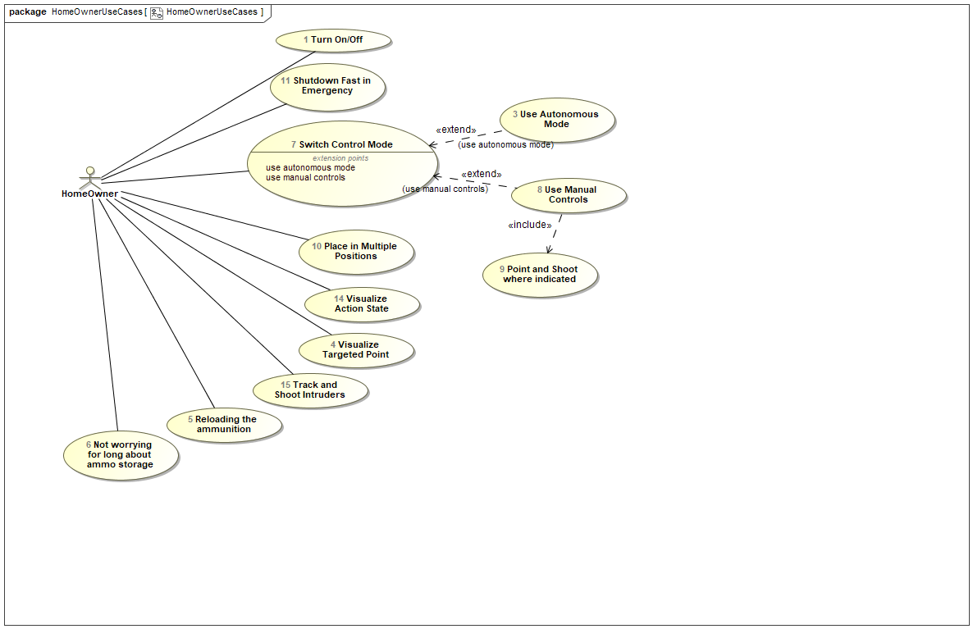

1. HomeOwnerUseCases

## MilitaryUseCases

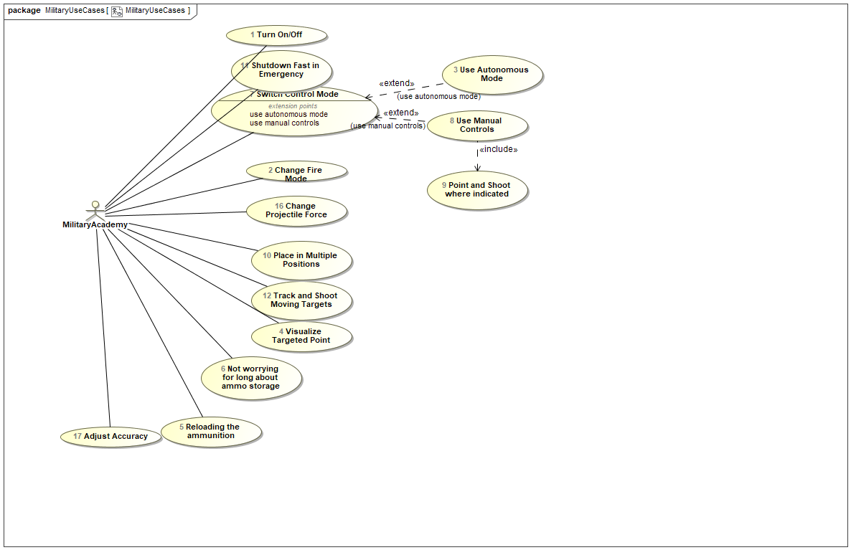

1. MilitaryUseCases

## EnterteinmentUseCases

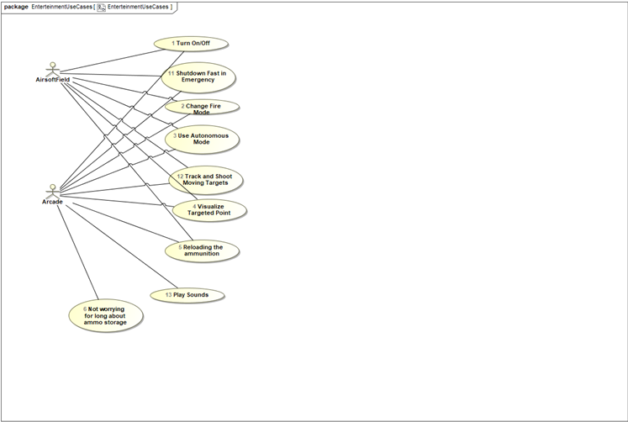

1. EnterteinmentUseCases

## UseCaseRequirements

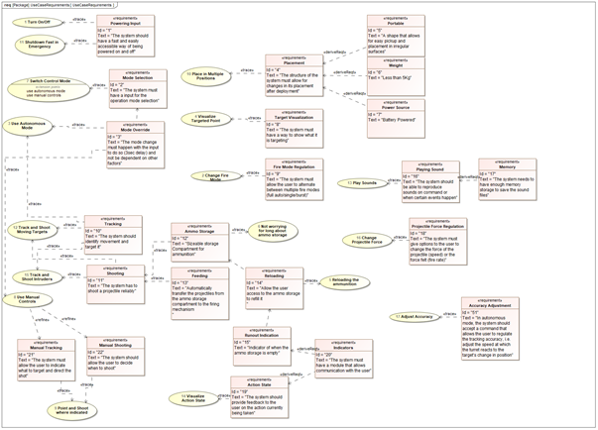

1. UseCaseRequirements

## GloveRequirements

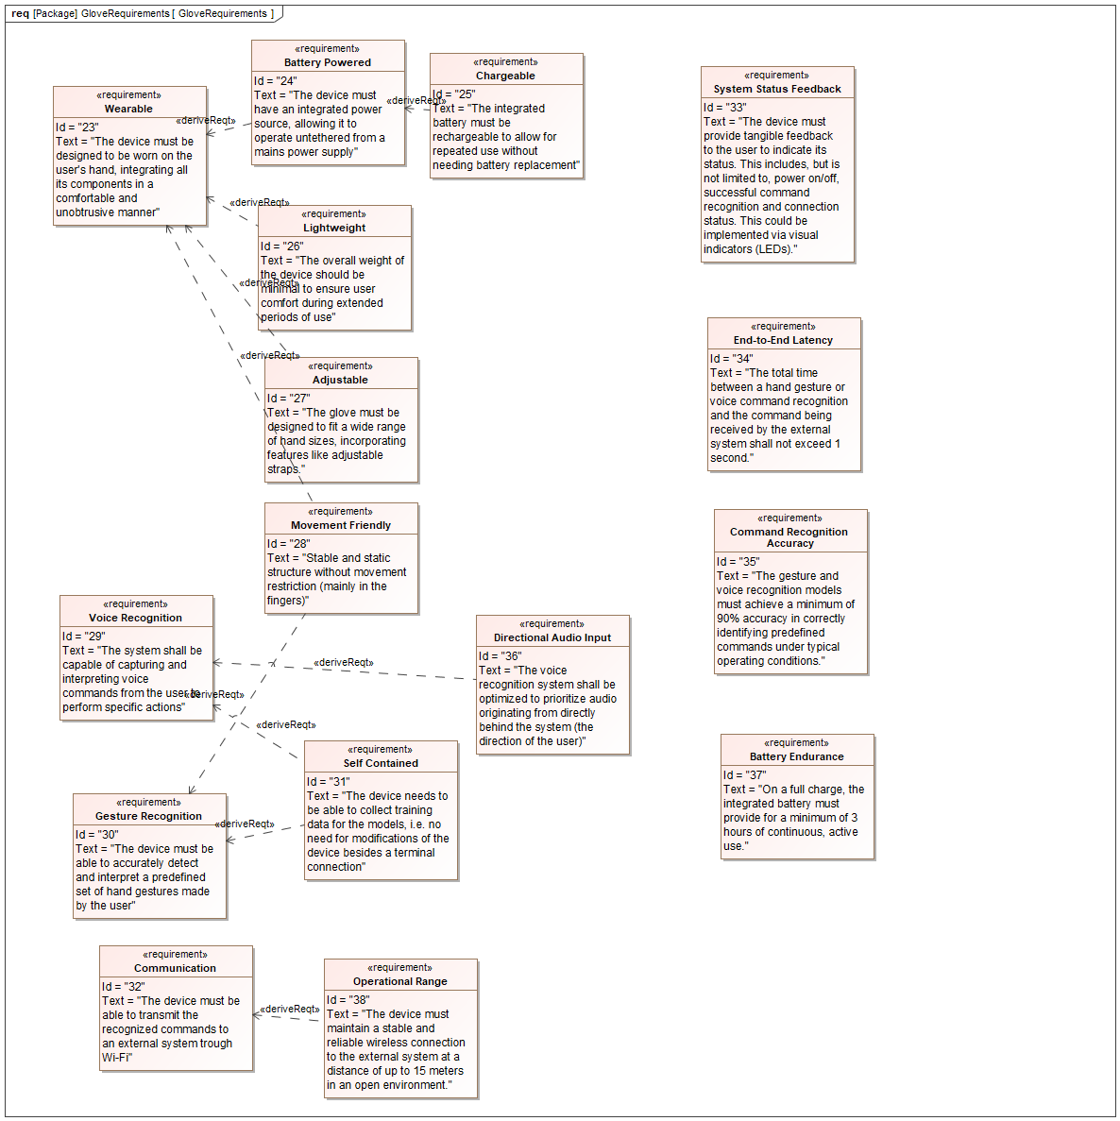

1. GloveRequirements

## TurretRequirements

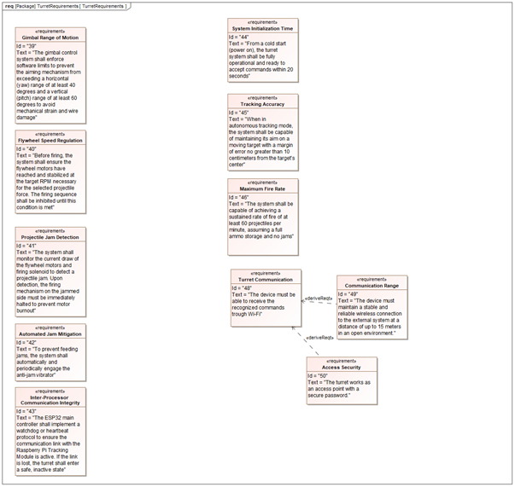

1. TurretRequirements

## Tests

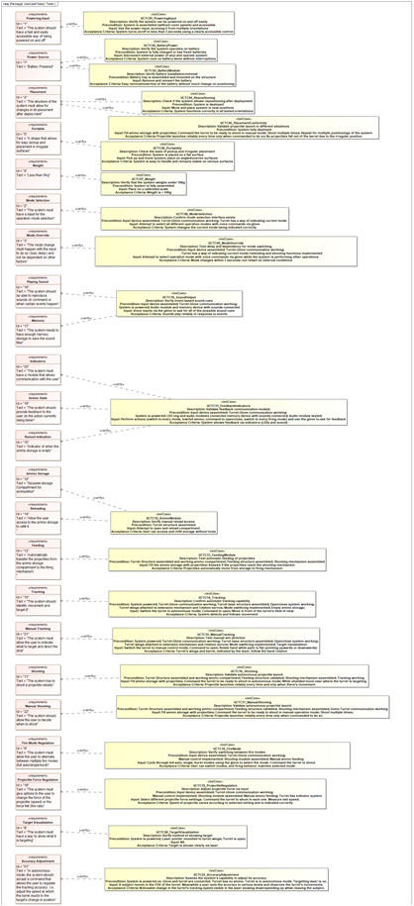

1. UseCase Tests

## GloveTests

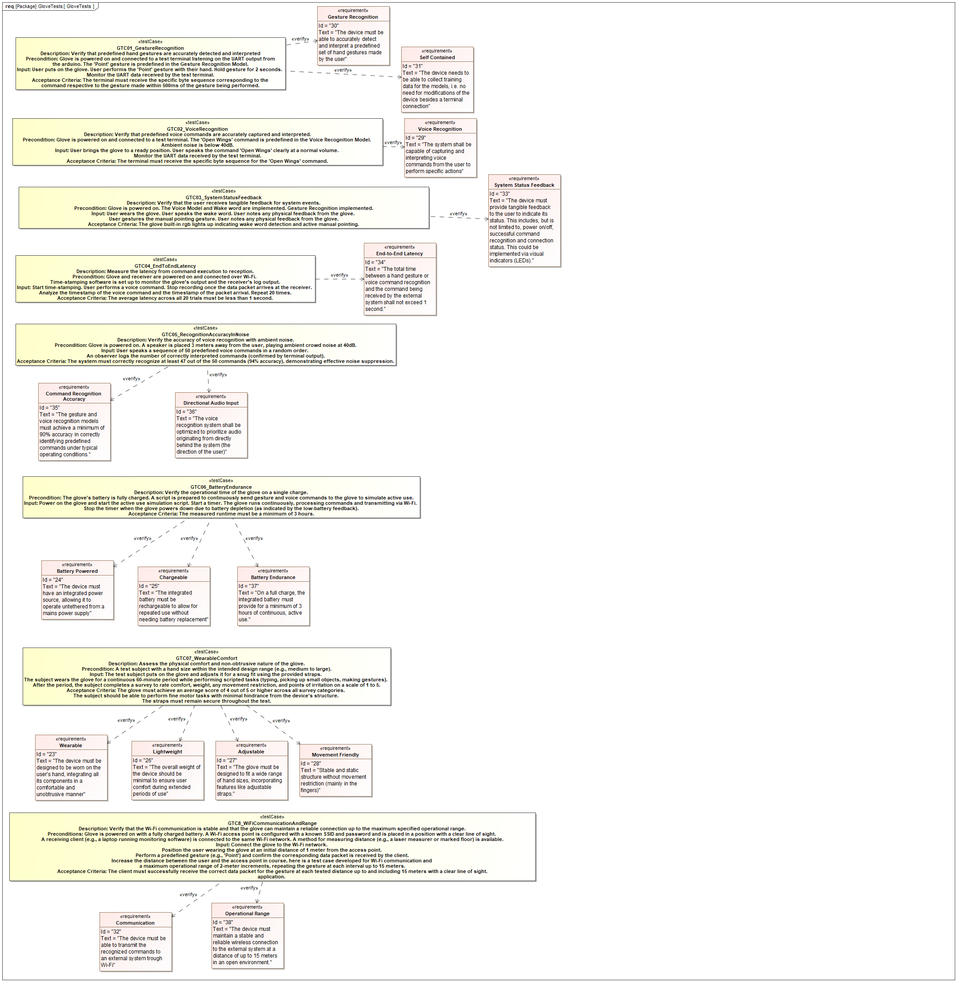

1. GloveTests

## TurretTests

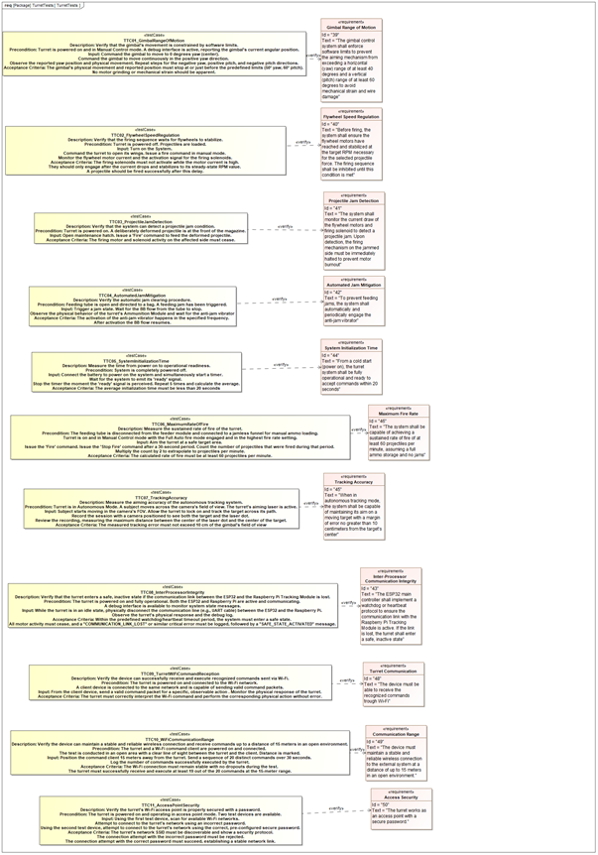

1. TurretTests

## GloveHardwareArchitecture

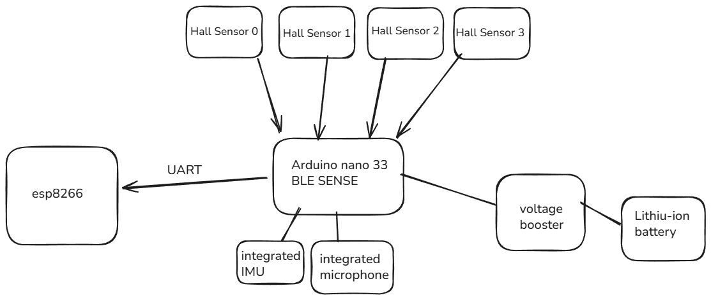

1. GloveHardwareArchitecture

## GloveSoftwareArchitecture

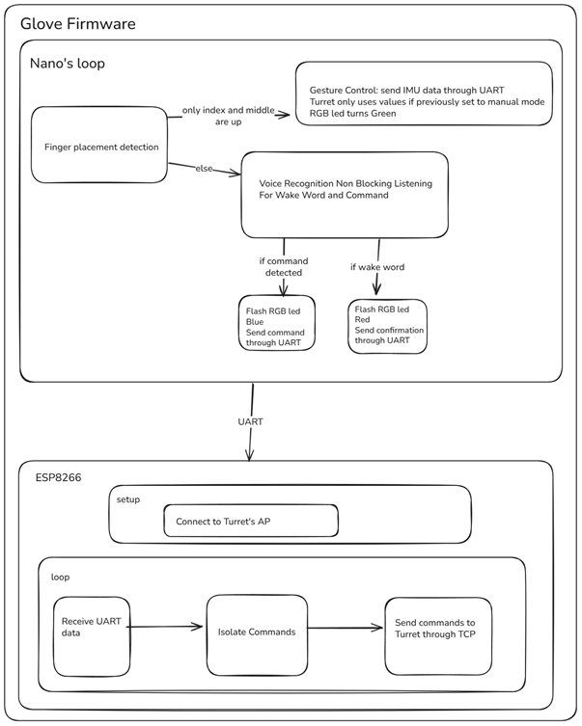

1. GloveSoftwareArchitecture

## TurretHardwareArchitecture

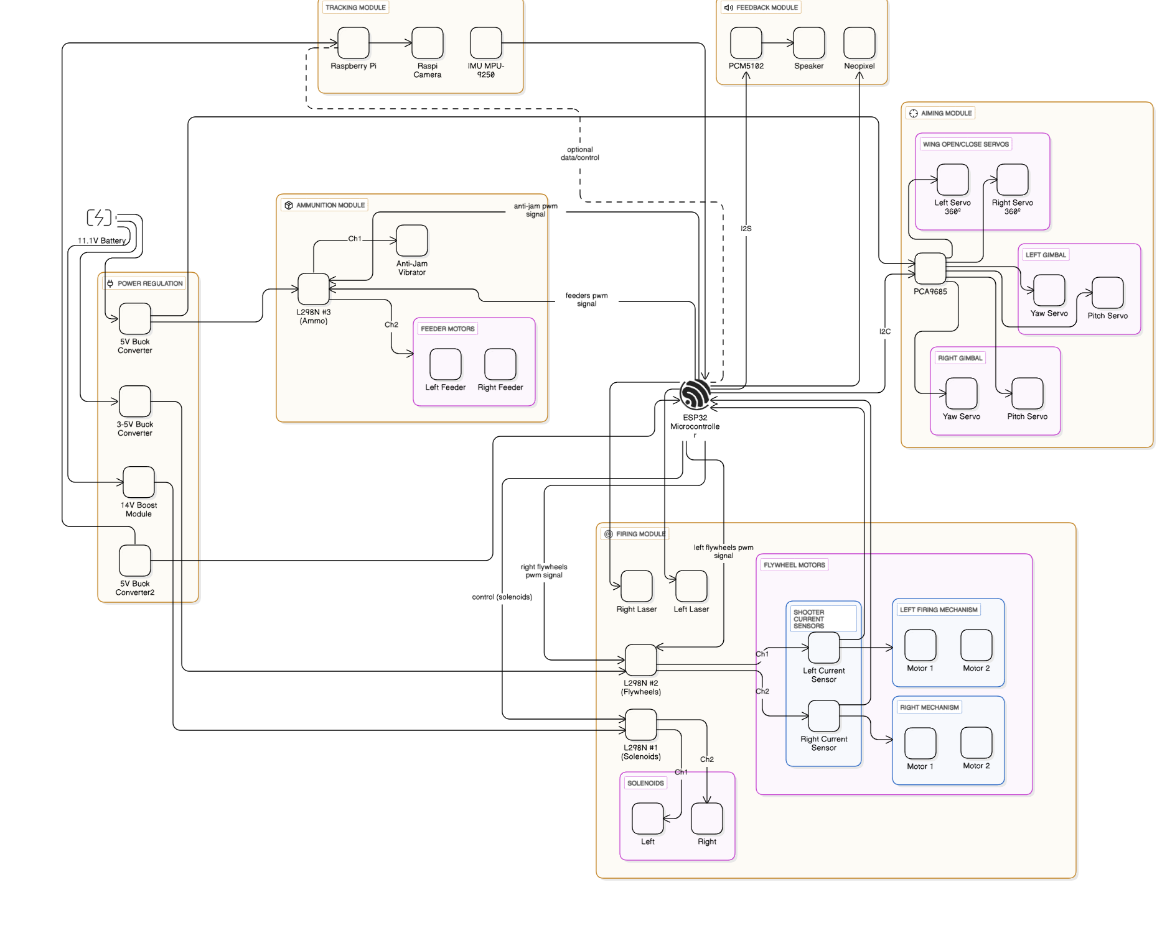

1. TurretHardwareArchitecture

## TurretSoftwareArchitecture

1. TurretSoftwareArchitecture

# Appendix B: Manufacturing and Assembly Process

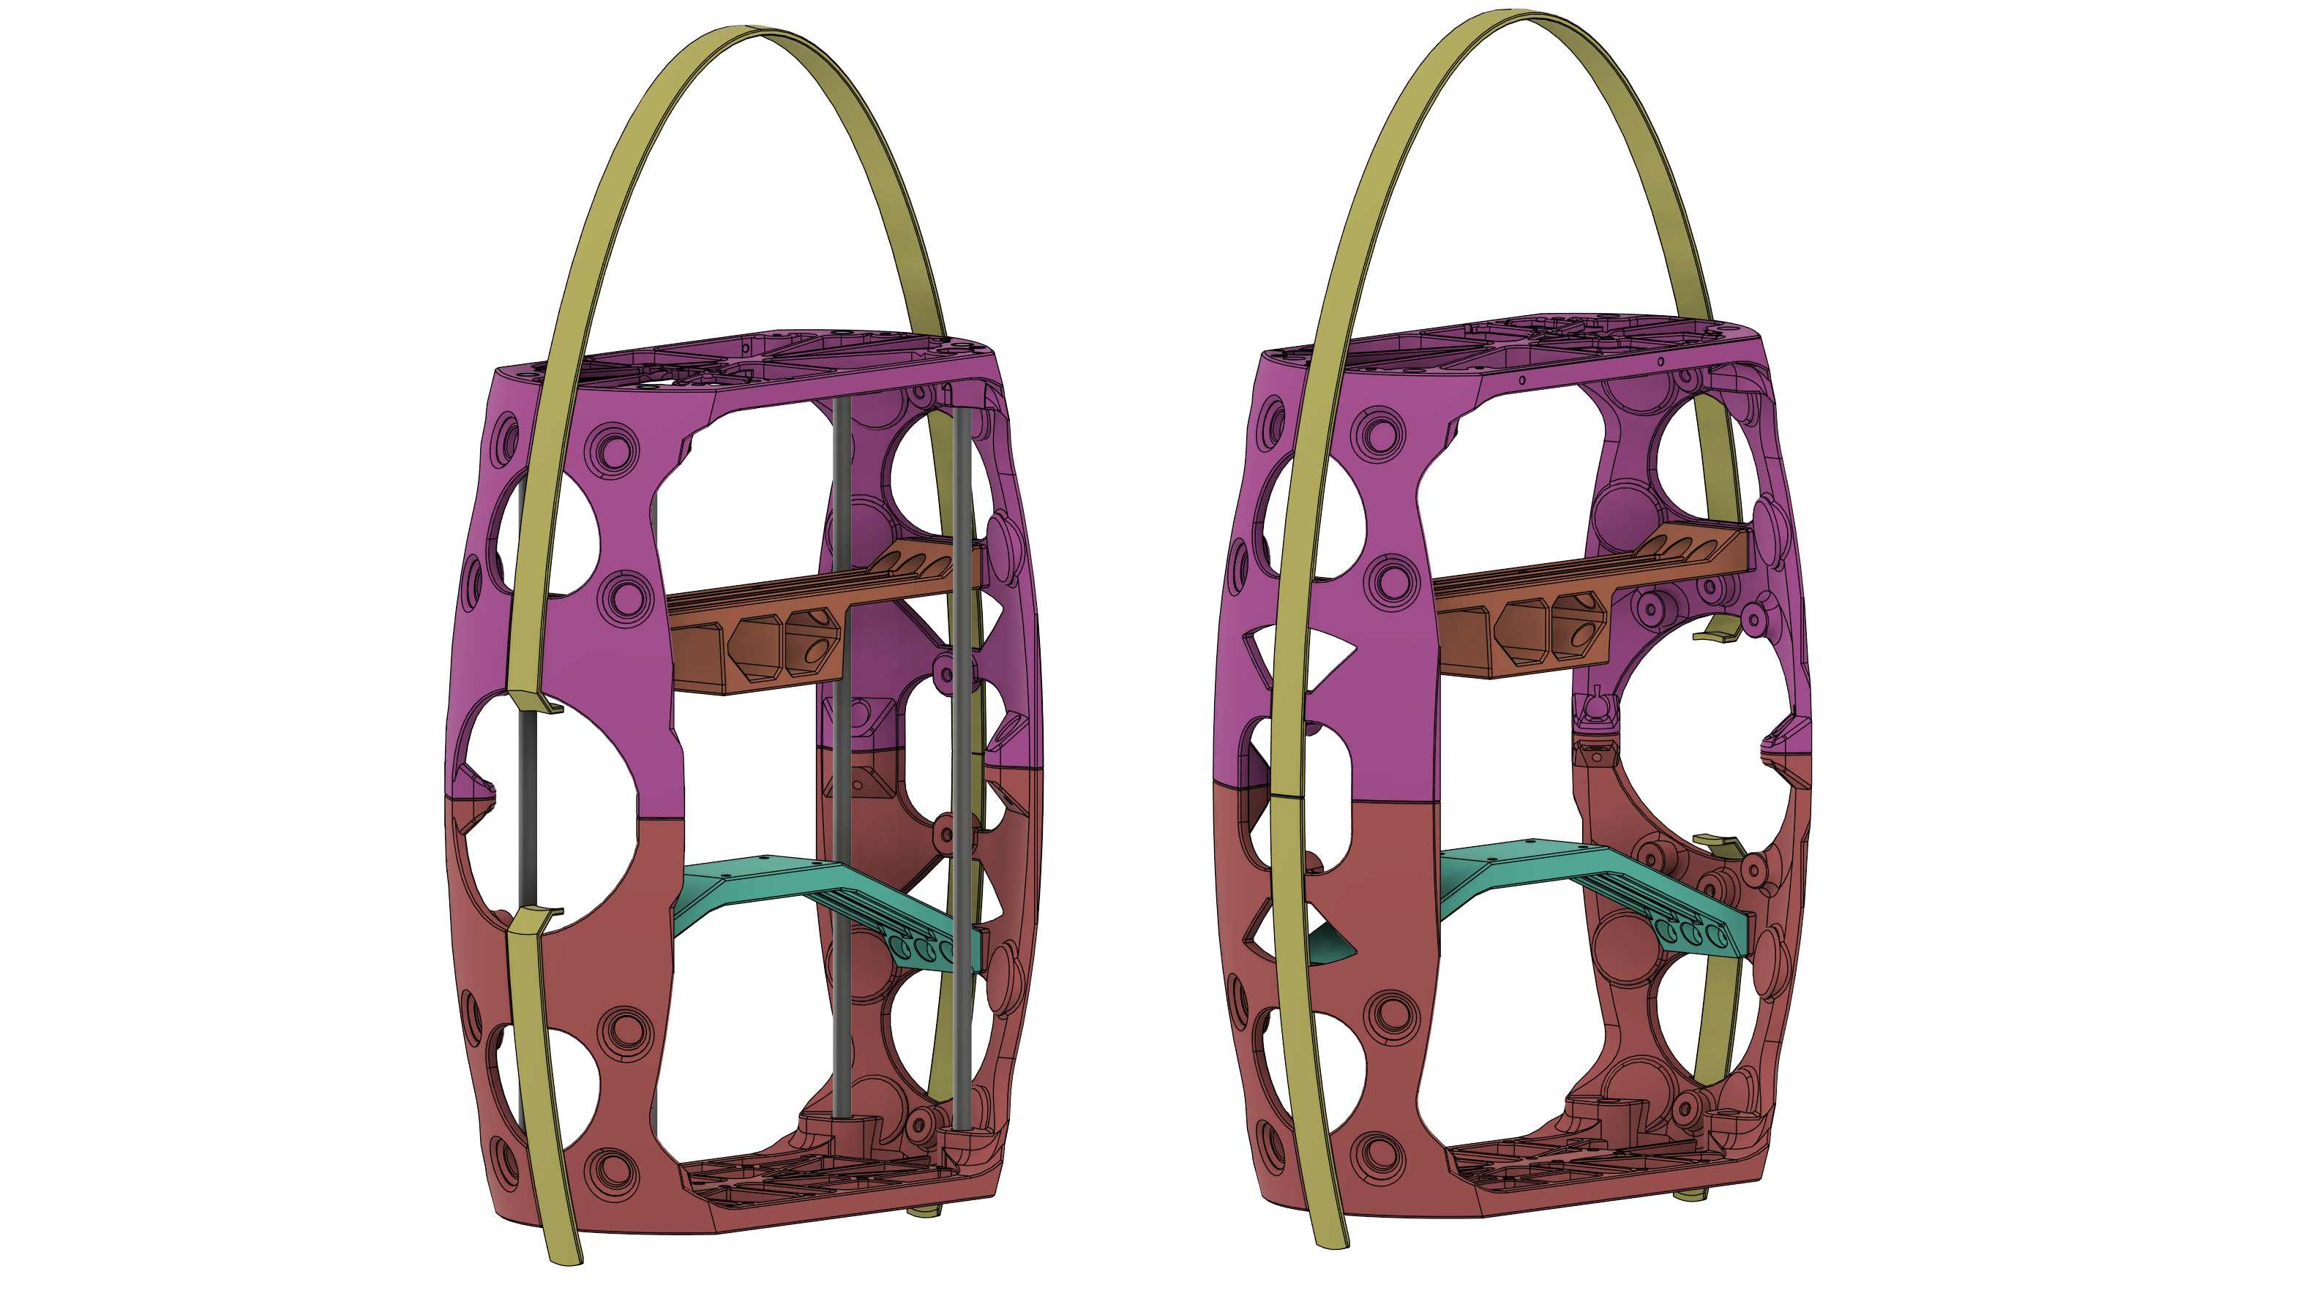

1. Turret Skeleton

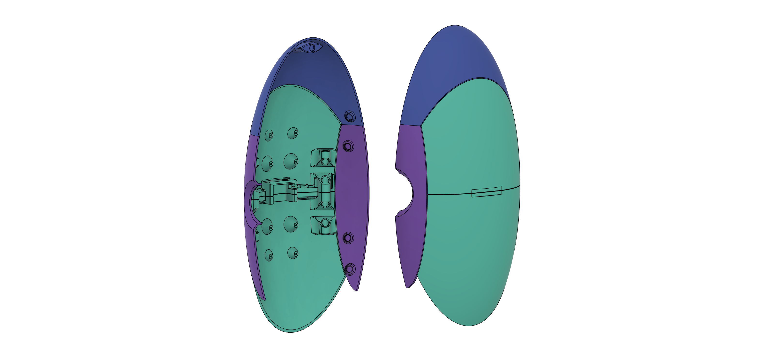

1. Turret Shell

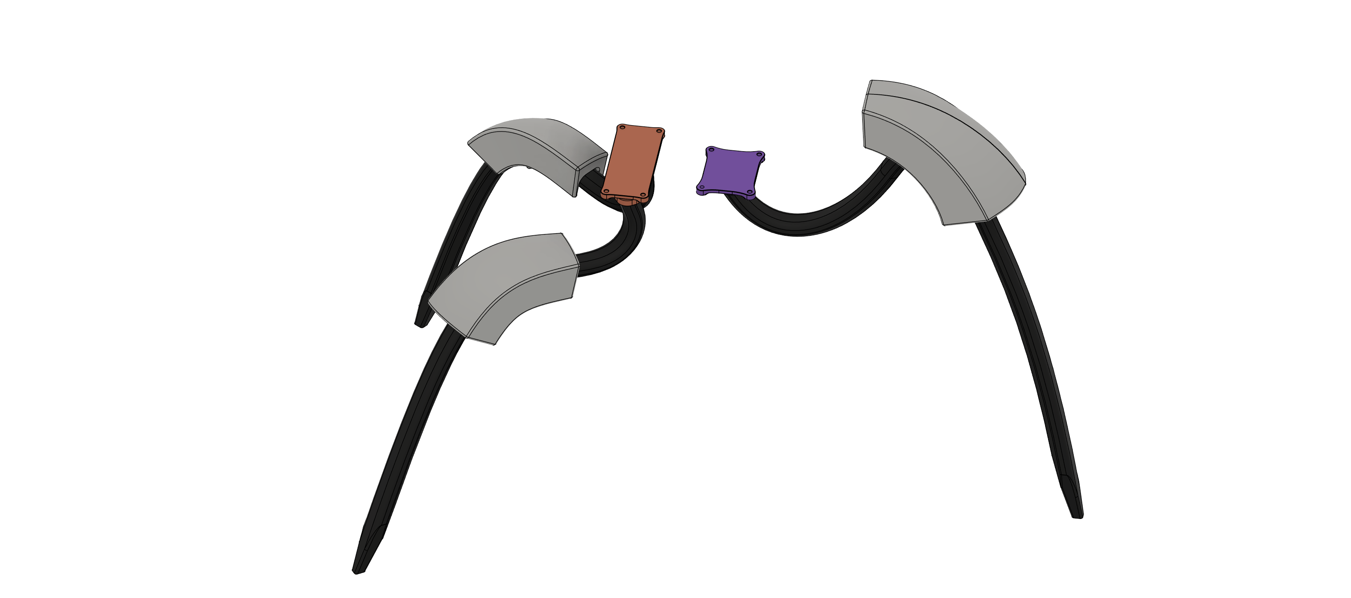

1. Turret Legs

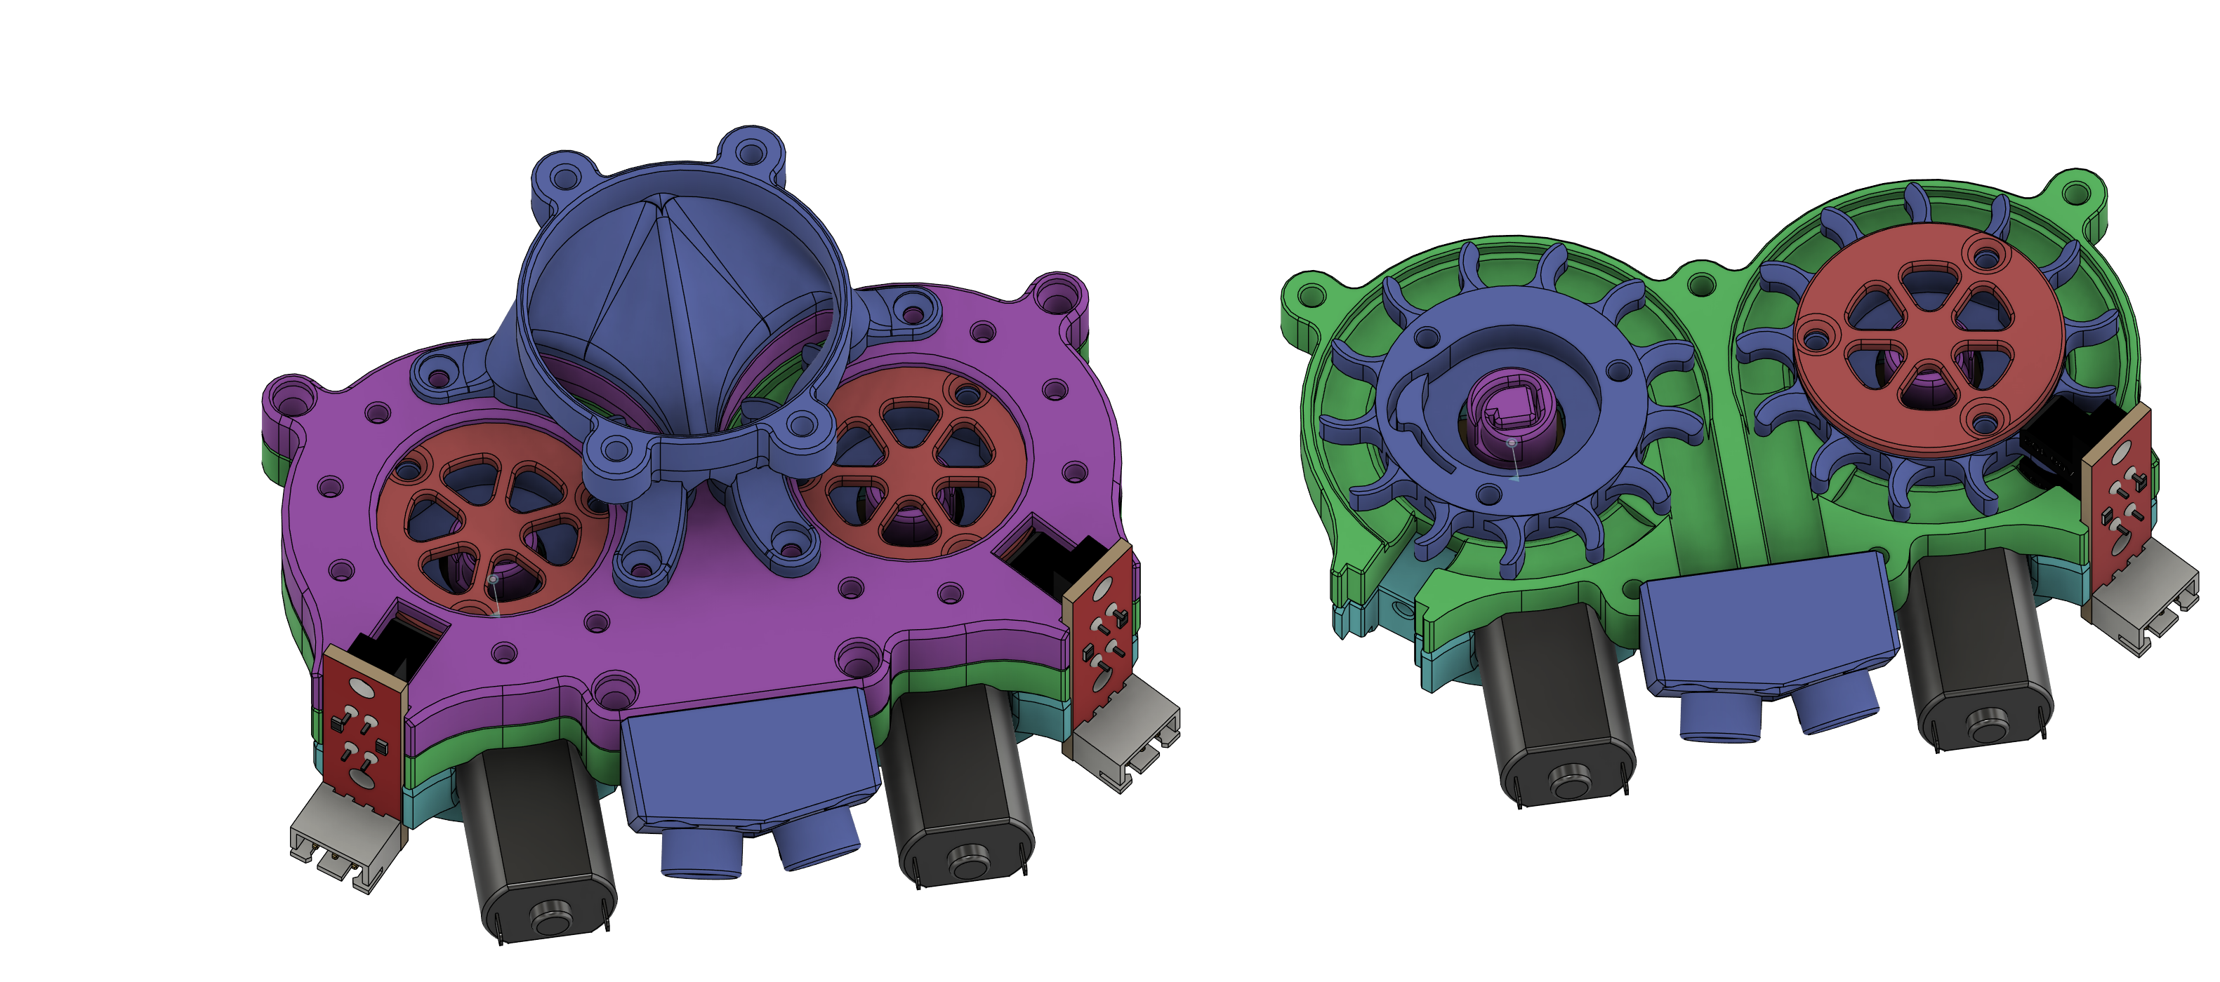

1. Feeder

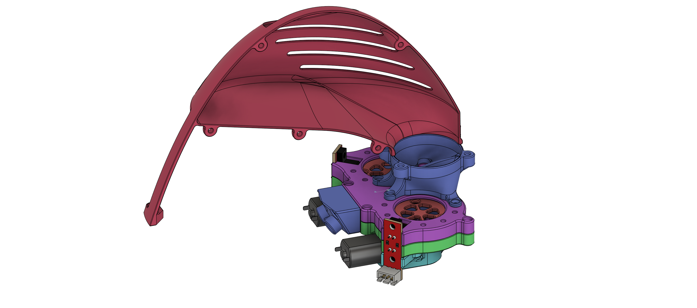

1. Feeder and Hopper

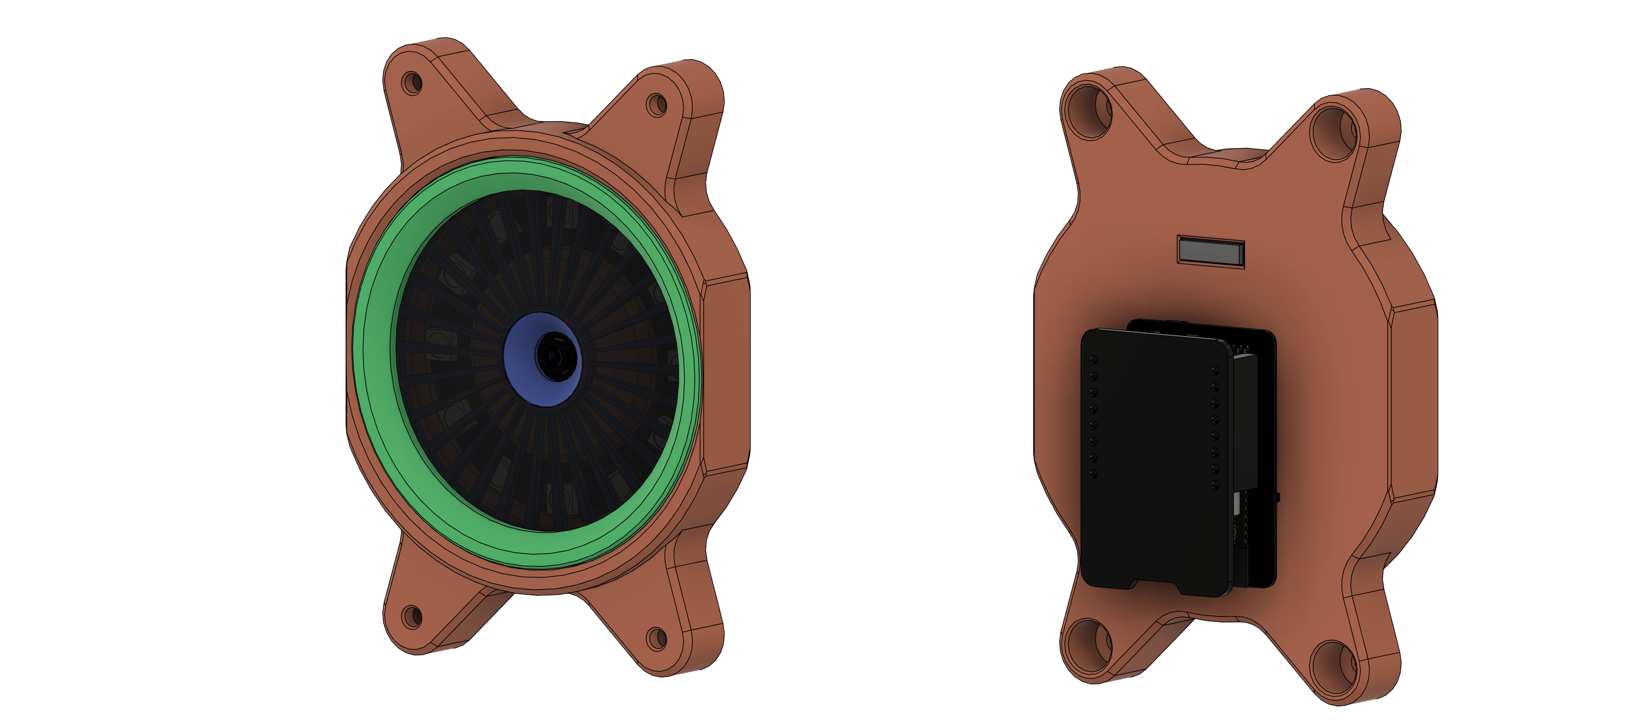

1. Eye (Neopixel and Camera)

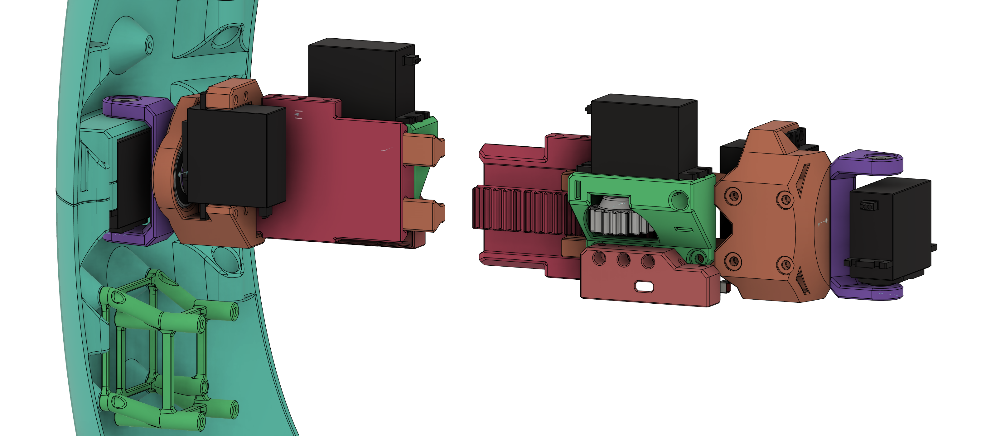

1. Extension Mechanism and Gimbal

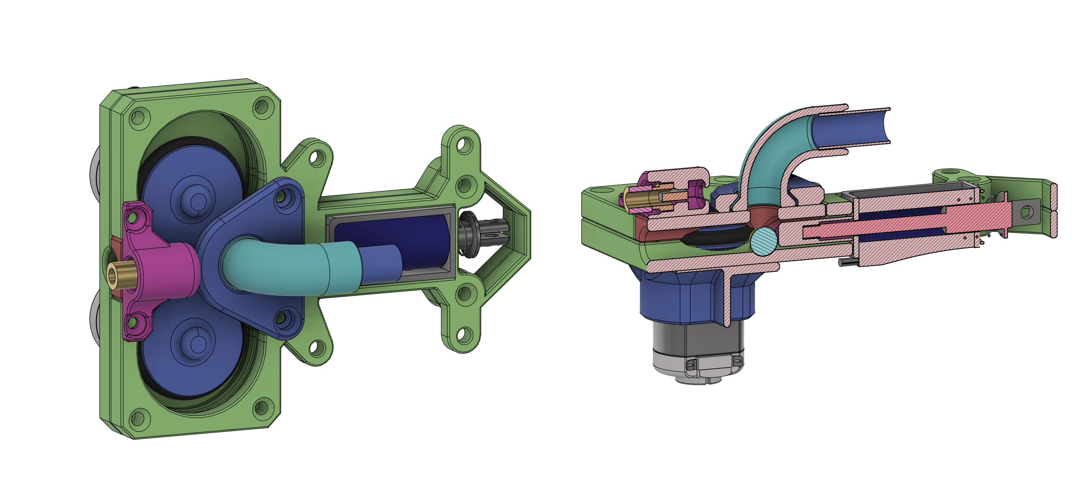

1. Firing Mechanism



1. Assembly Stage 0

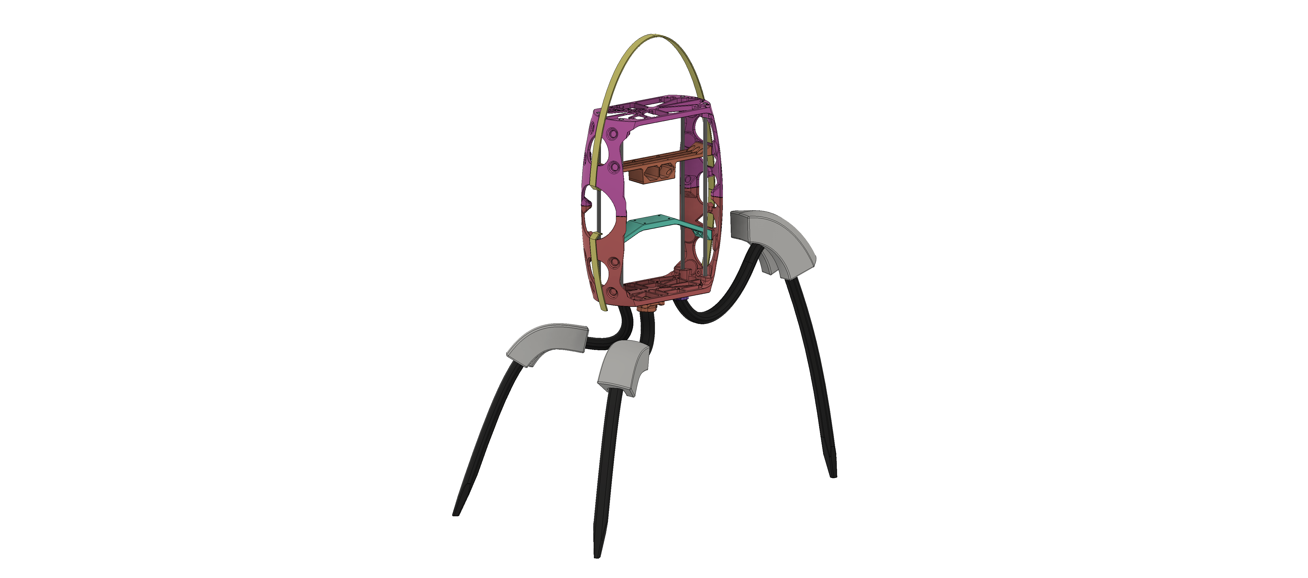

1. Assembly Stage 1

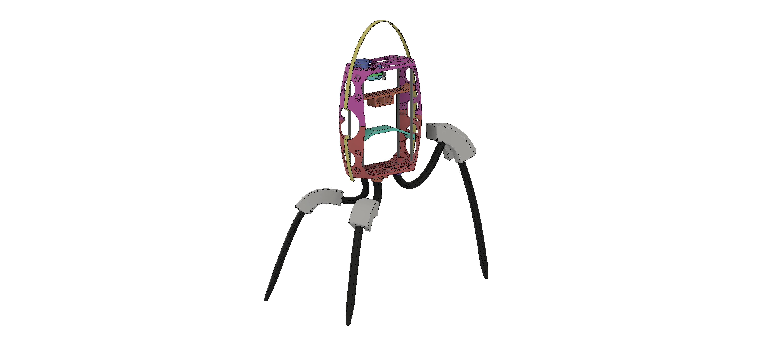

1. Assembly Stage 2

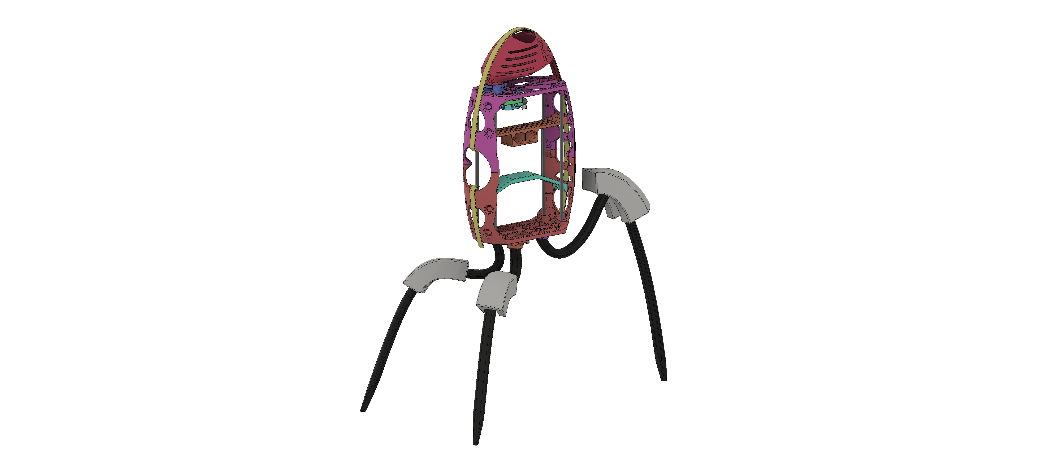

1. Assembly Stage 3

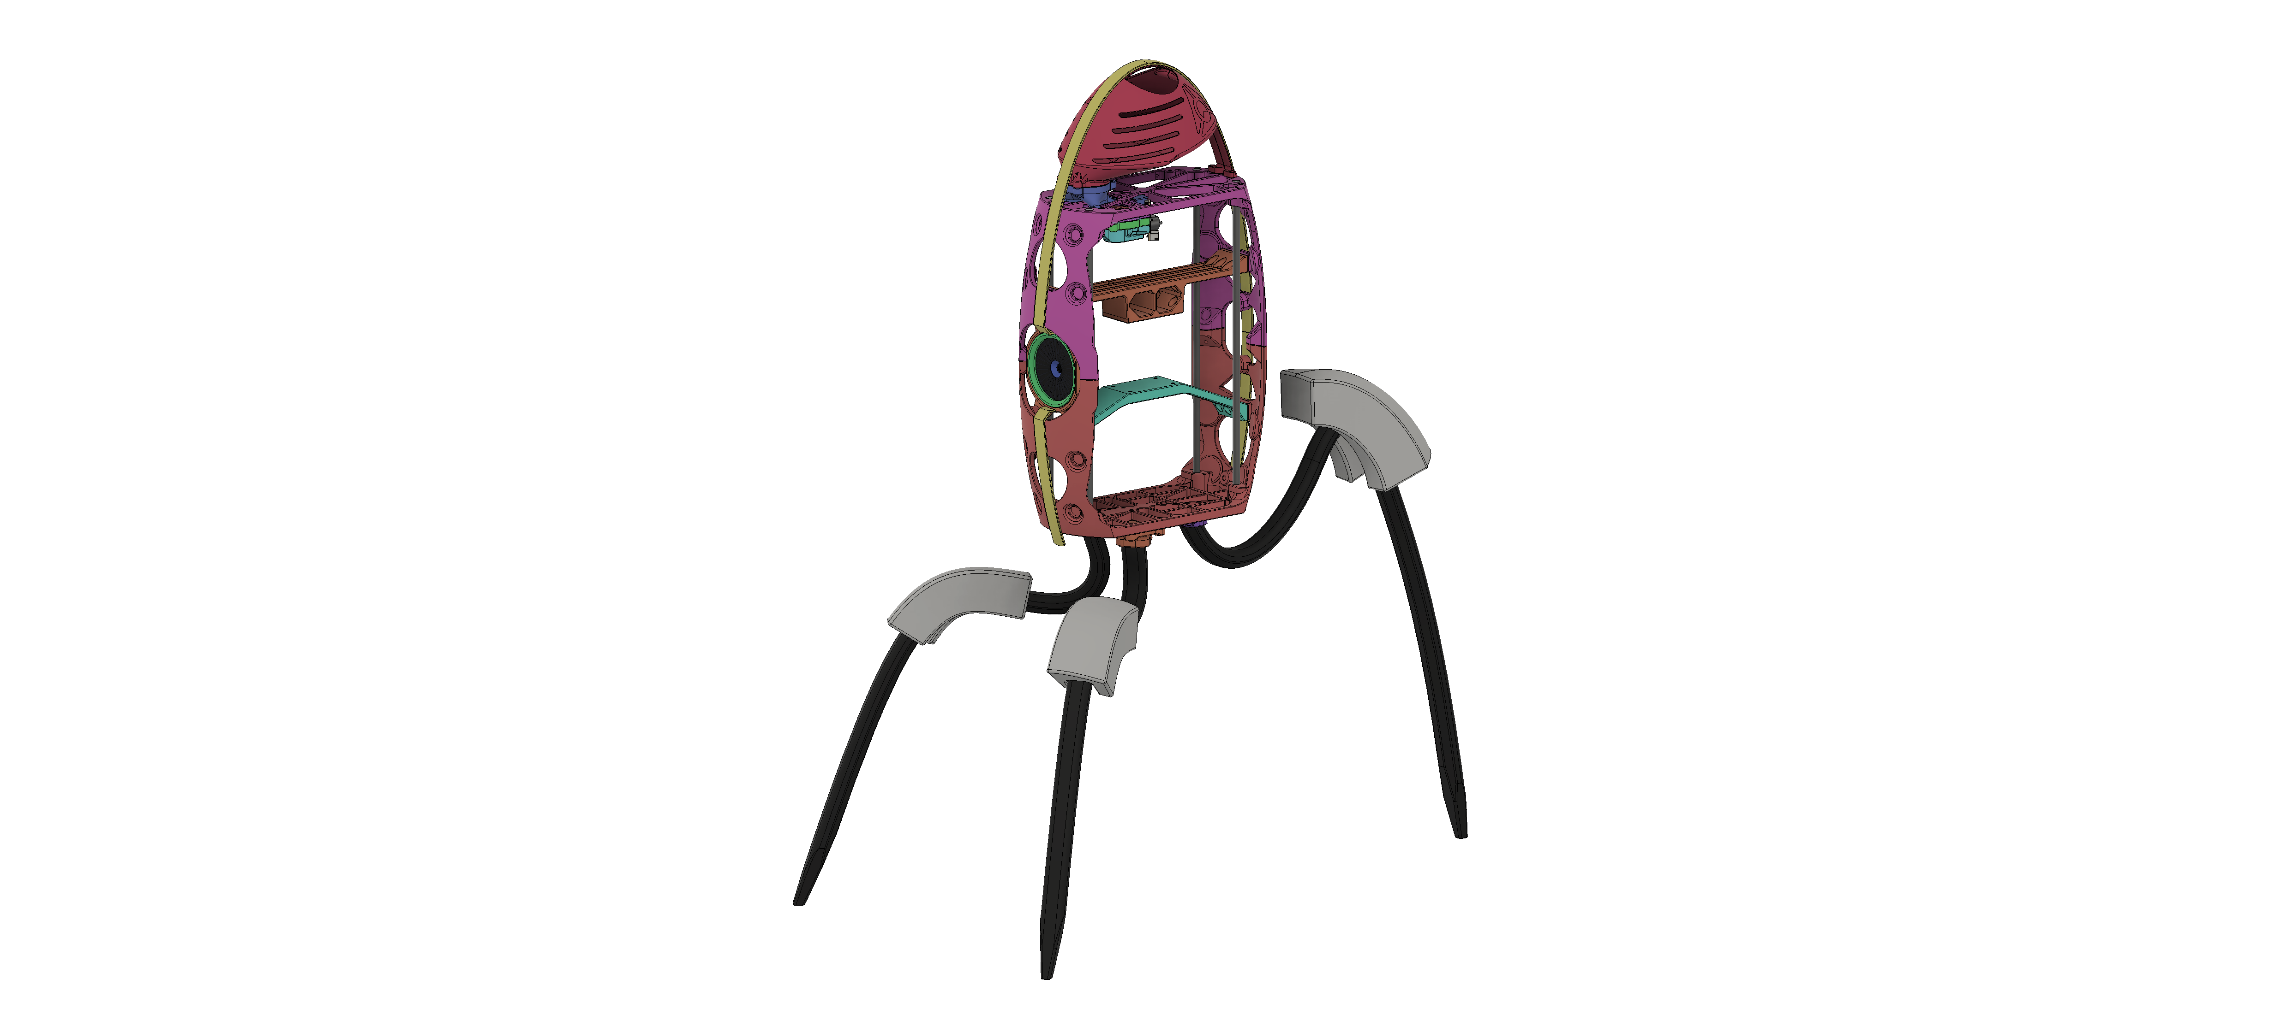

1. Assembly Stage 4

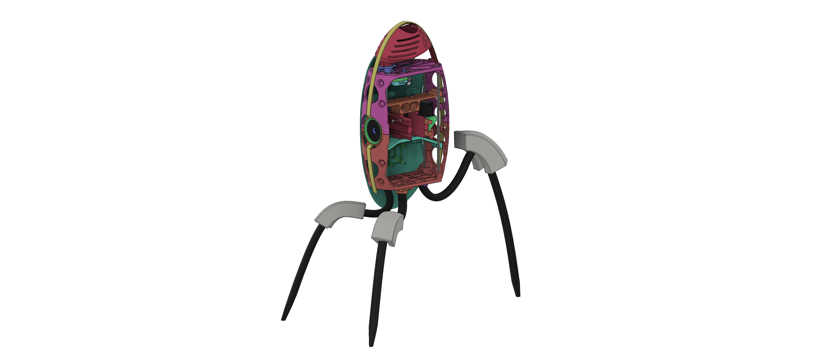

1. Assembly Stage 5

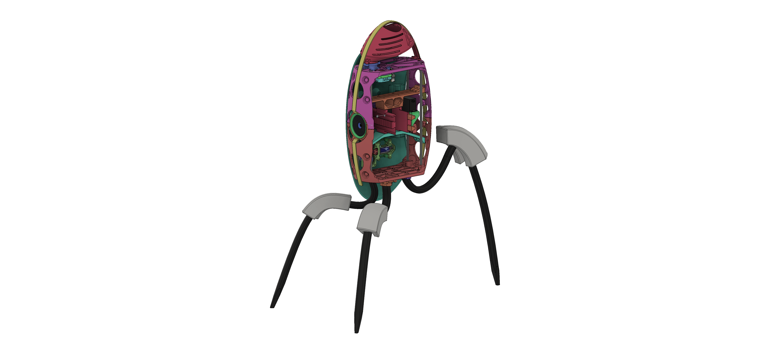

1. Assembly Stage 6

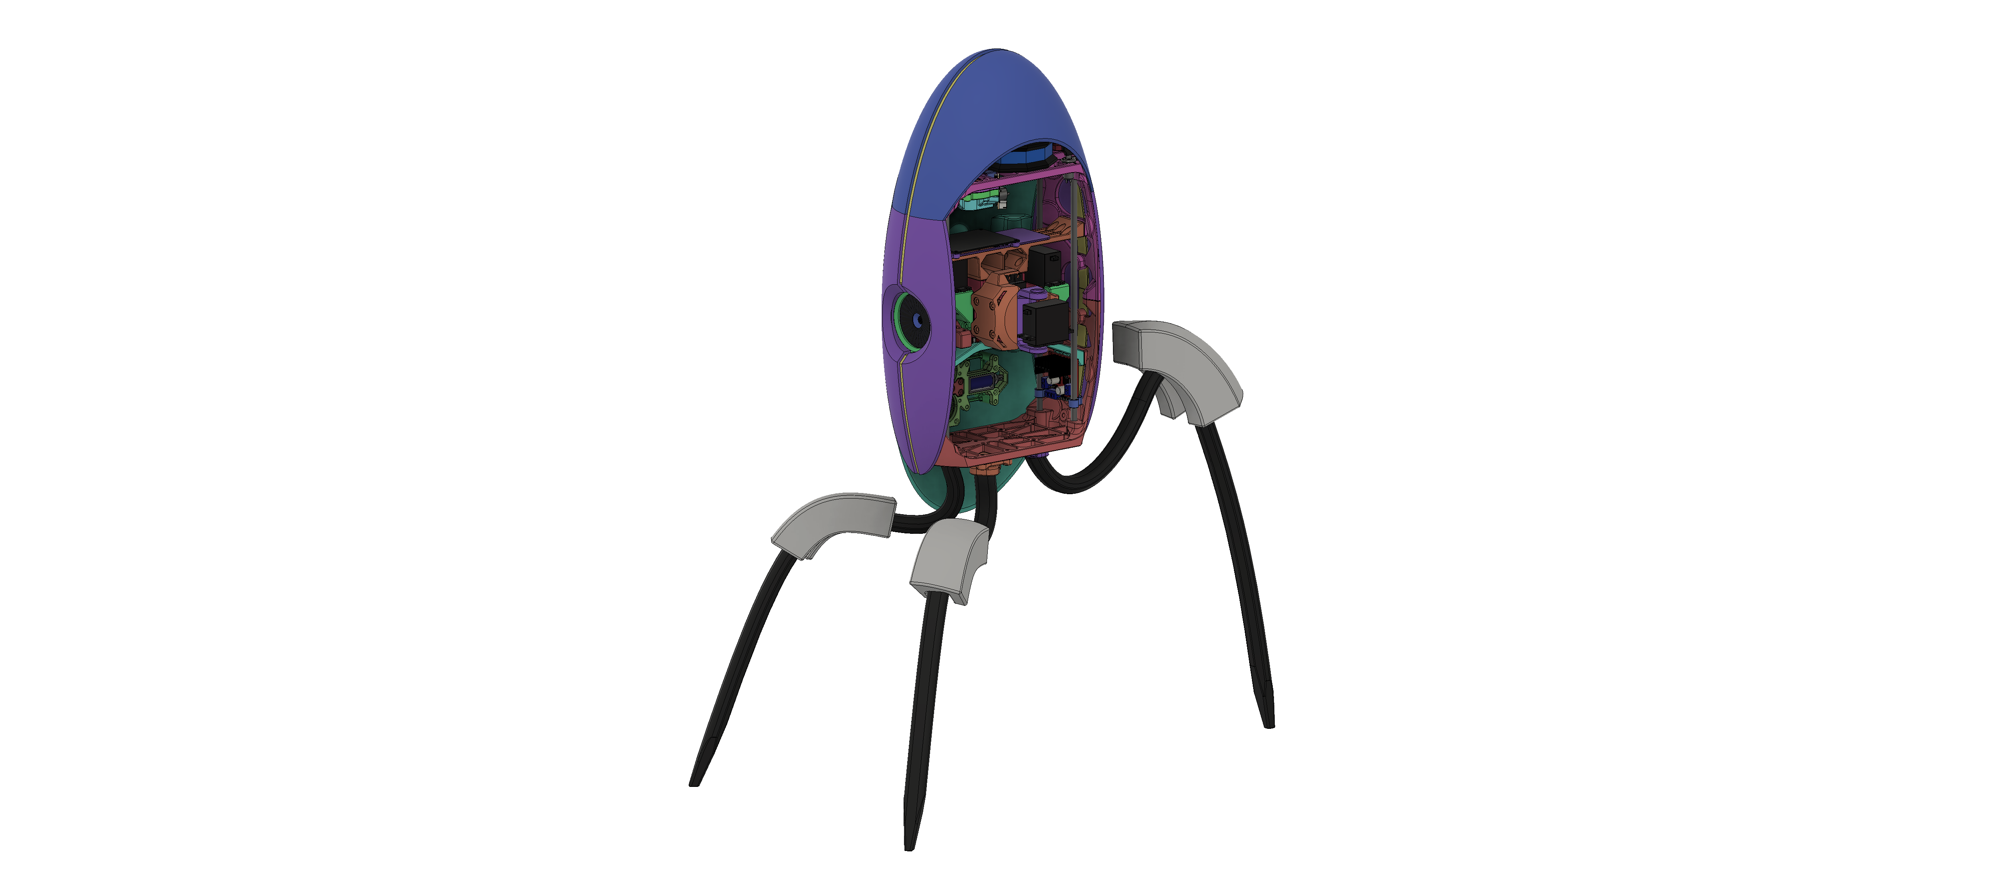

1. Assembly Stage 7

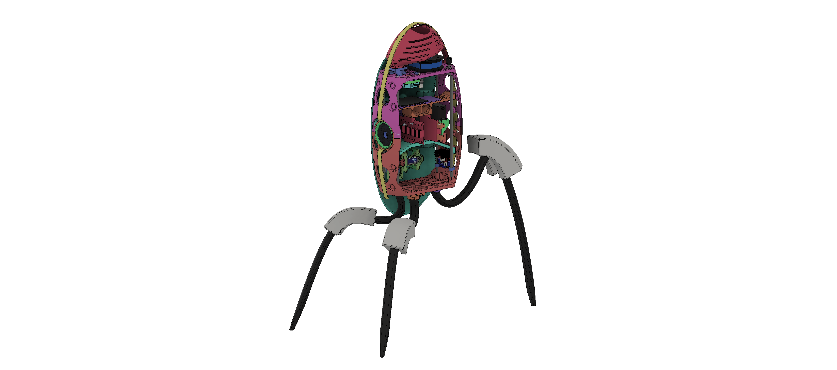

1. Assembly Stage 8

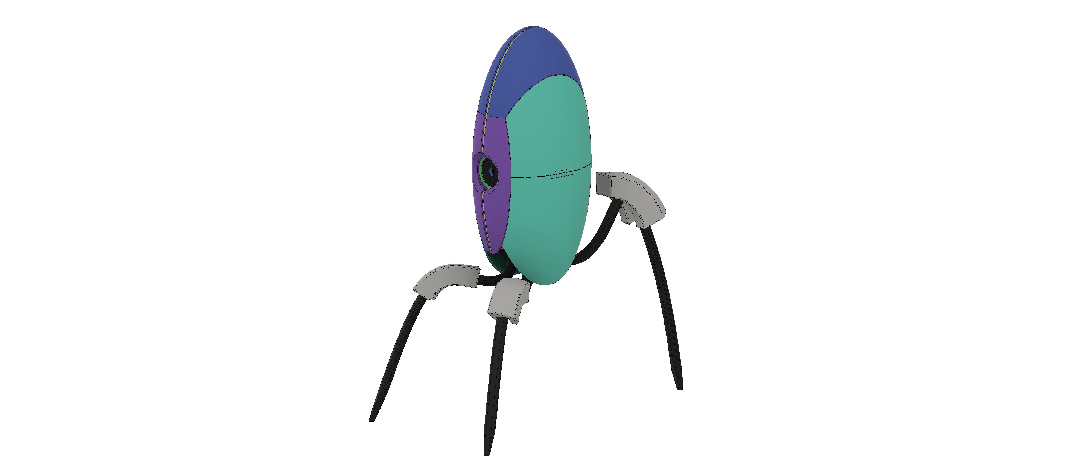

1. Assembly Stage 9 – Complete Render